**Figure S31**. Relative age groups of the analysed specimens of *Ondatra zibethicus*: (A) ZIN 32560; (B) ZIN 69584; (C) ZIN 84176.

Skulls are shown in lateral (top) and dorsal (bottom) views. (E1–E3) Lateral radiographs of molar roots (root-bearing species only). Scale bars are 5 mm; skulls are shown at the same scale.

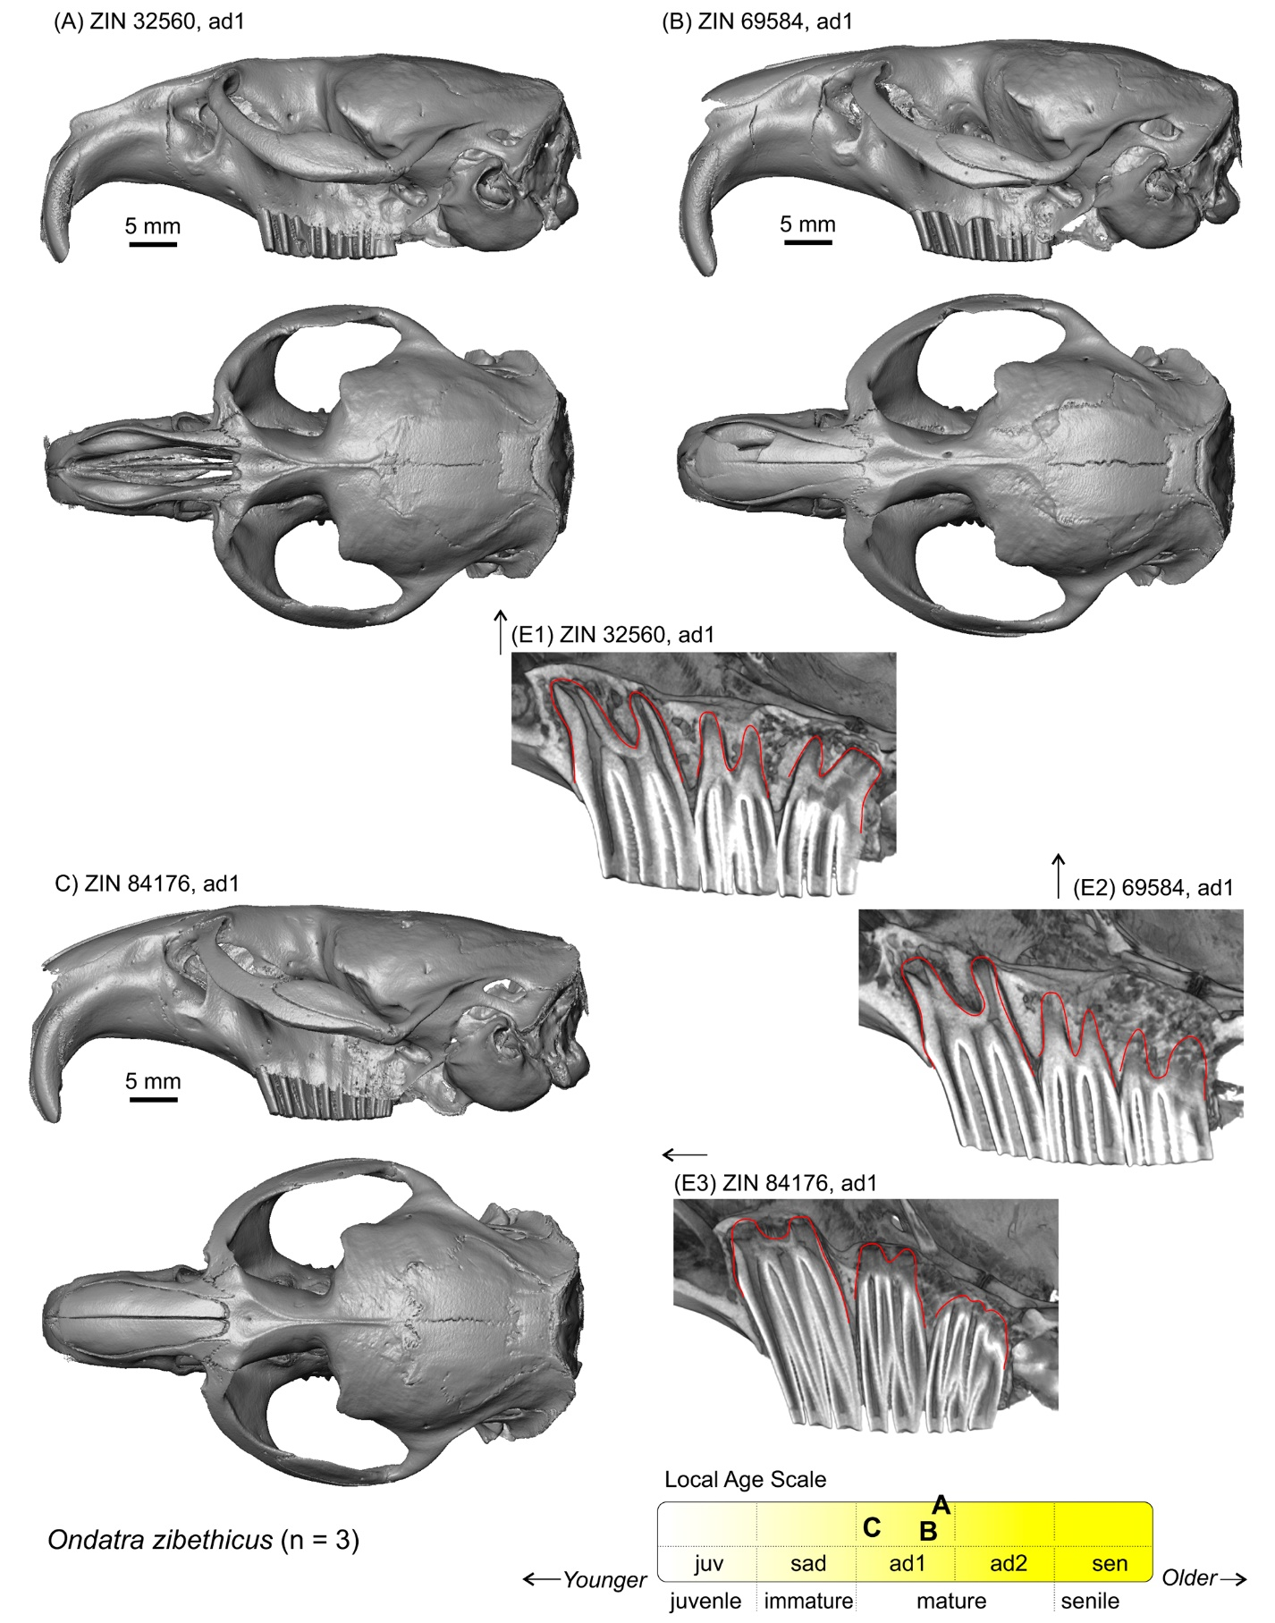

**Figure S32**. Relative age groups of the analysed specimens of *Prometheomys schaposchnikowi*: (A) ZIN 31495; (B) ZIN 74487.

Skulls are shown in lateral (top) and dorsal (middle) views. Bottom images show lateral radiographs of molar roots (root-bearing species only). Scale bars are 5 mm; skulls are shown at the same scale. *Key*: **a**, the temporal line.

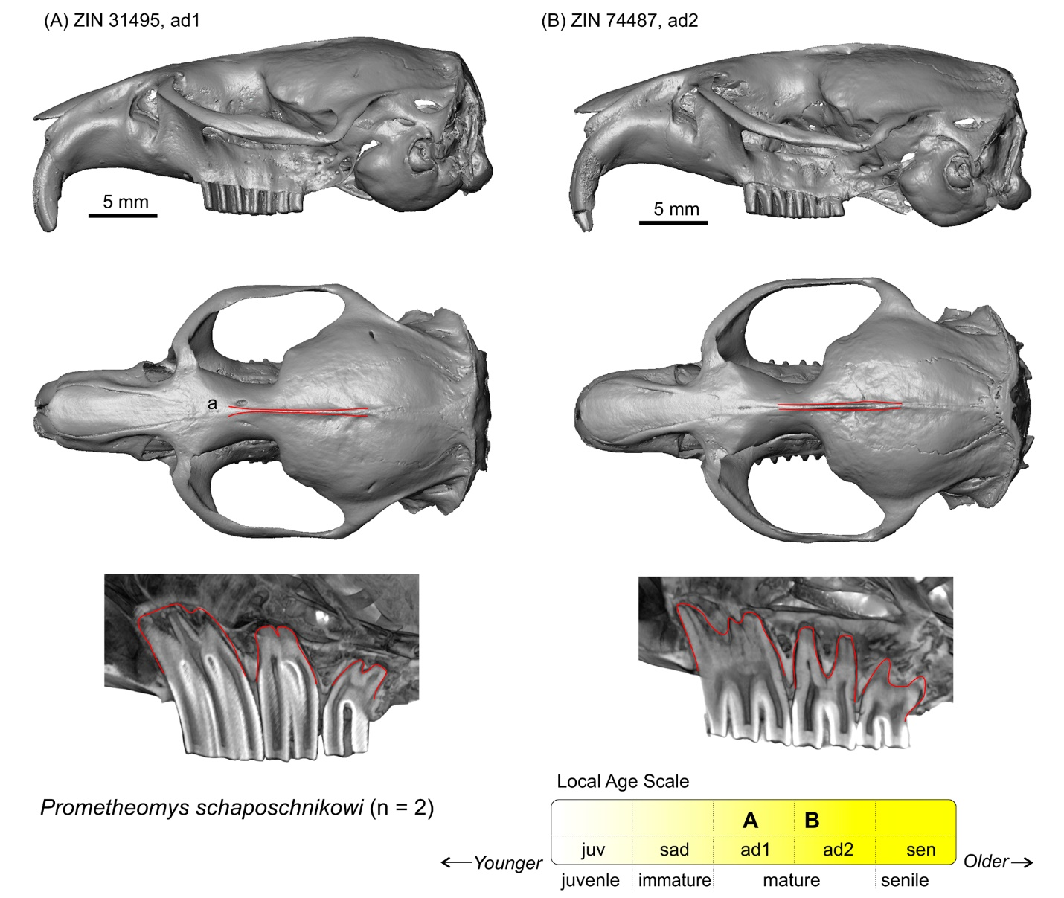

**Figure S33**. Relative age groups of the analysed specimens of *Terricola subterraneus*: (A) ZIN 74969; (B) ZIN 80937; (C) ZIN 84244.

Skulls are shown in lateral (top) and dorsal (bottom) views. Scale bars are 5 mm; skulls are shown at the same scale. *Key*: **a**, line marks the profile of the zygomatic arch in a mature specimen compared to an immature specimen.

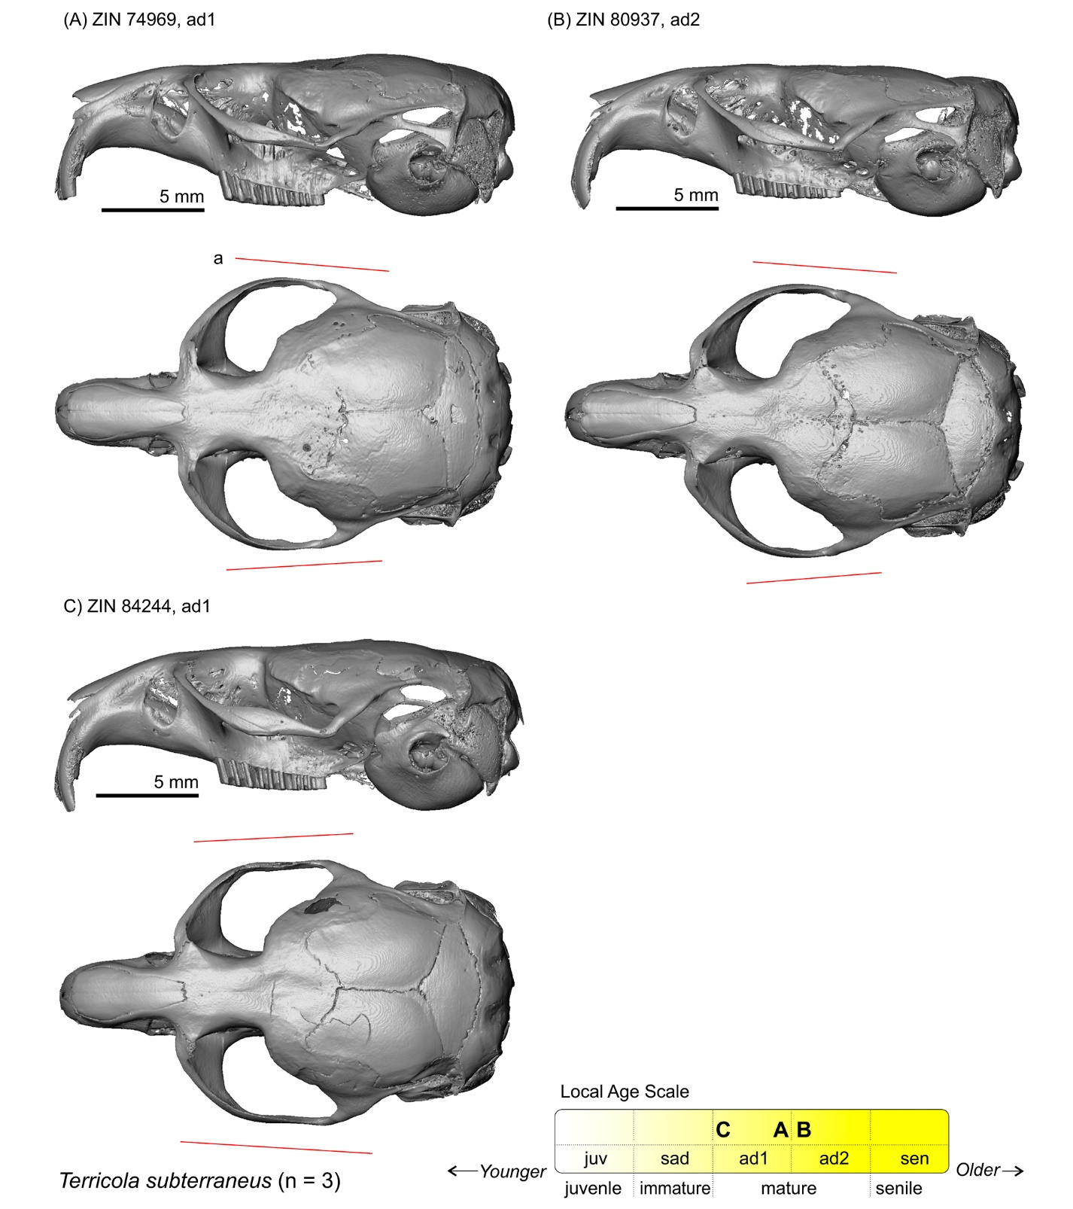

**Figure S34**. Relative age groups of the analysed specimens of *Neotoma mexicana*: (A) ZIN 39375; (B) ZIN 39376.

Skulls are shown in lateral (top) and dorsal (middle) views. Bottom images show lateral radiographs of molar roots (root-bearing species only). Scale bars are 5 mm; skulls are shown at the same scale. *Key*: **a**, the temporal line.

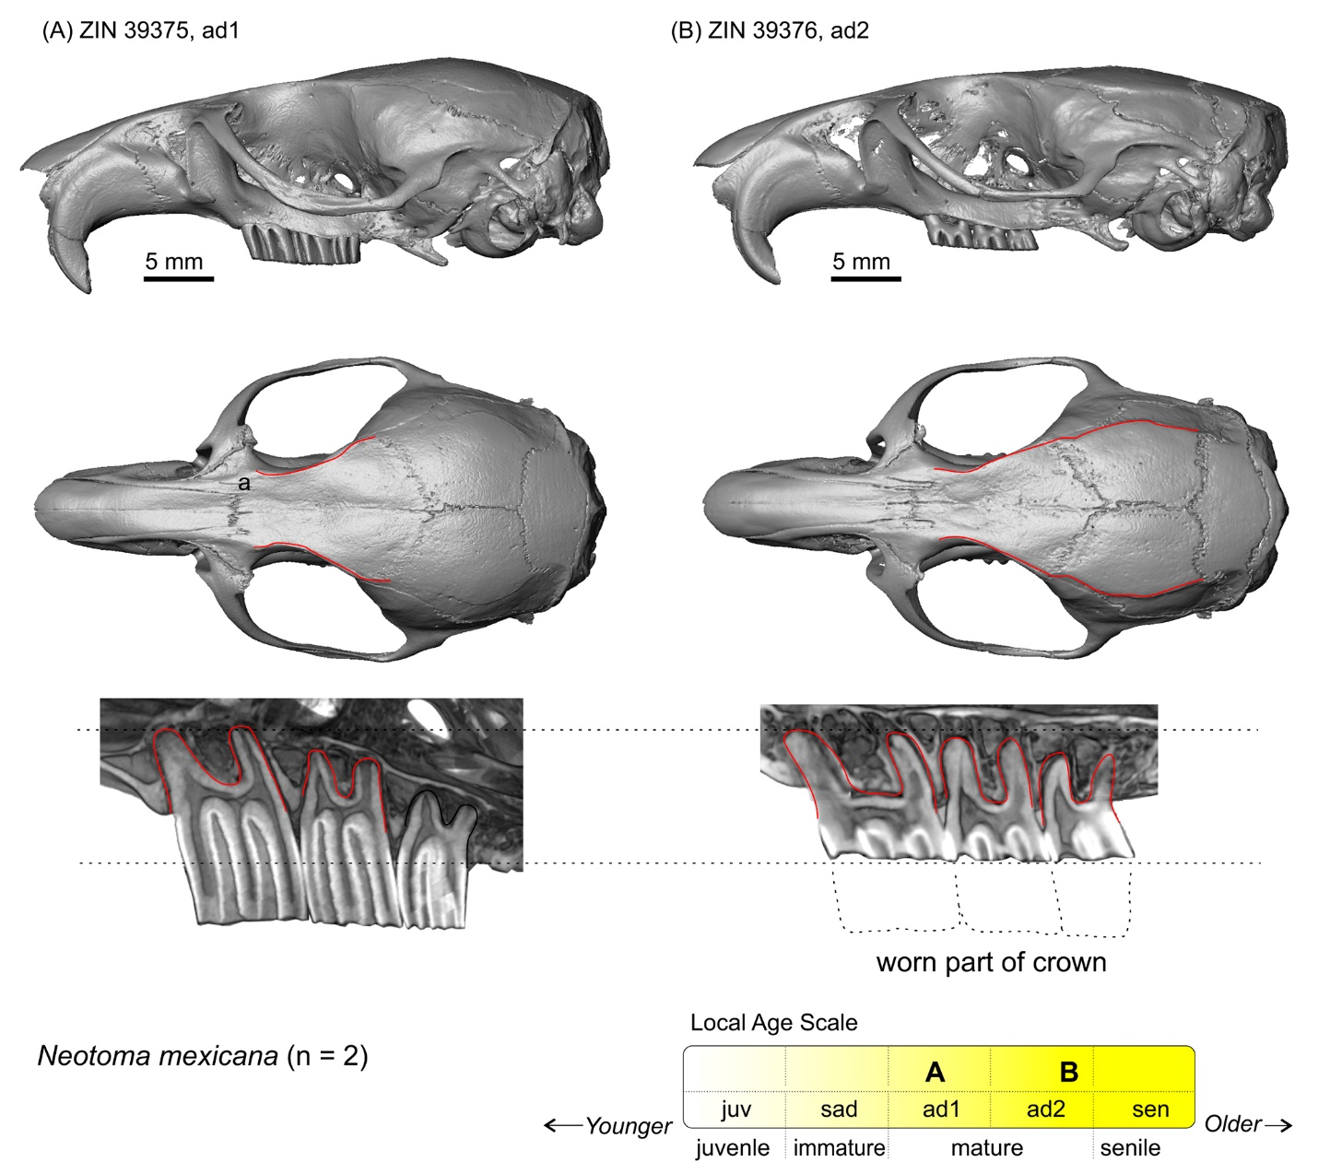

**Figure S35**. Screenshots of the PSP complex in subposterior view of specimen ZIN 101697 of *Cricetulus barabensis* with landmark positions (left).

Skull in lateral (top, right) and dorsal (middle, right) view. The lower images show lateral radiographs of molar roots (root-bearing species only) and the upper row of teeth in occlusal view. Scale bar is 5 mm.

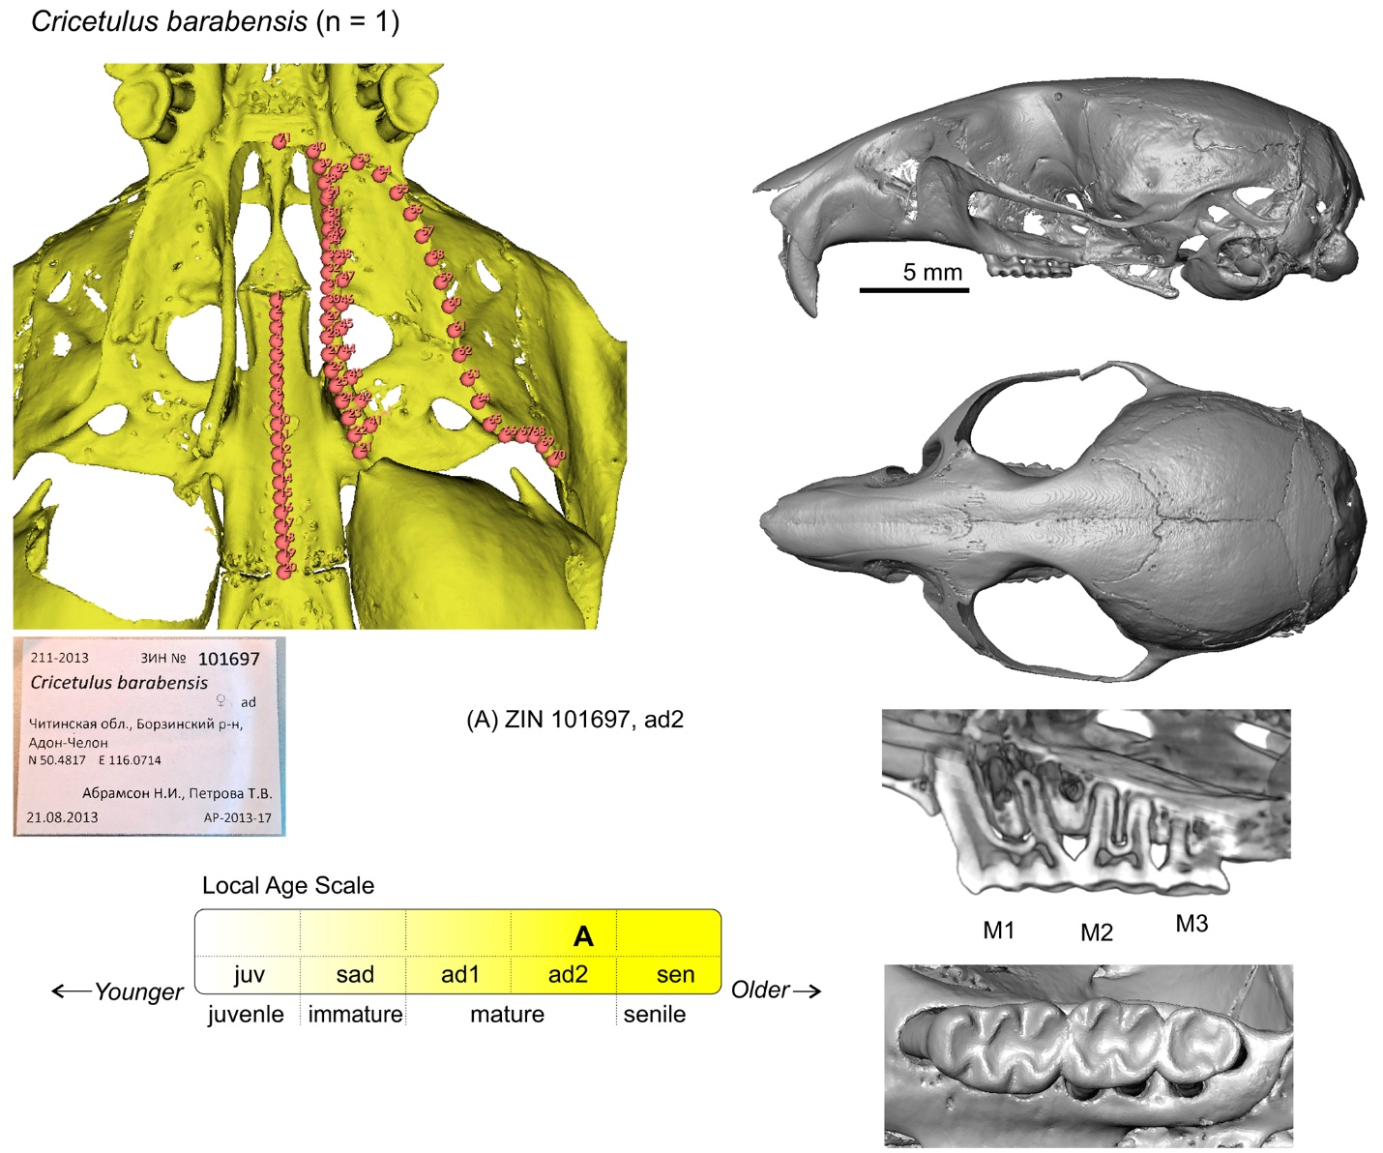

**Figure S36**. Screenshots of the palato-spheno-pterygoid complex (PSP complex) in posterior view of four specimens of *Agricola agrestis* with landmark positions: (A) ZIN 89132; (B) ZIN 16897; (C) ZIN 97312; (D) ZIN 98482.

Each screenshot is accompanied by a label image. Screenshots taken from 3D Slicer space to show variation in the posterior palatal margin and adjacent structures. Not scaled.

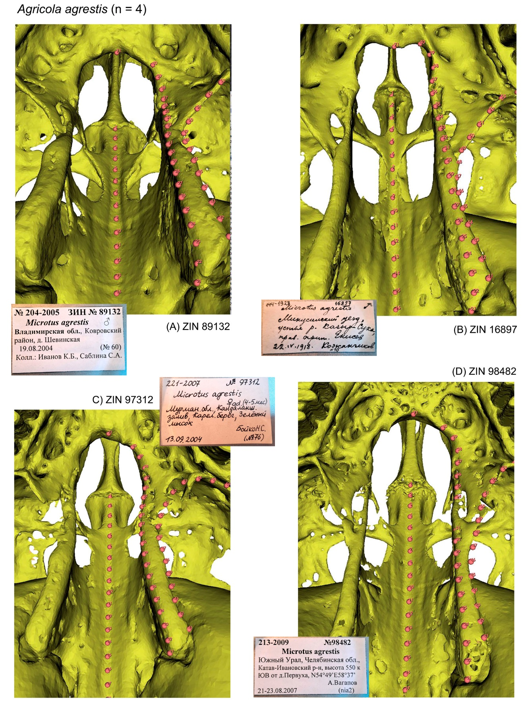

**Figure S37**. Screenshots of the PSP complex in subposterior view of two specimens of *Alexandromys fortis* with landmark positions: (A) ZIN 83881; (B) ZIN 105505.

See figure S36 for details. Not scaled.

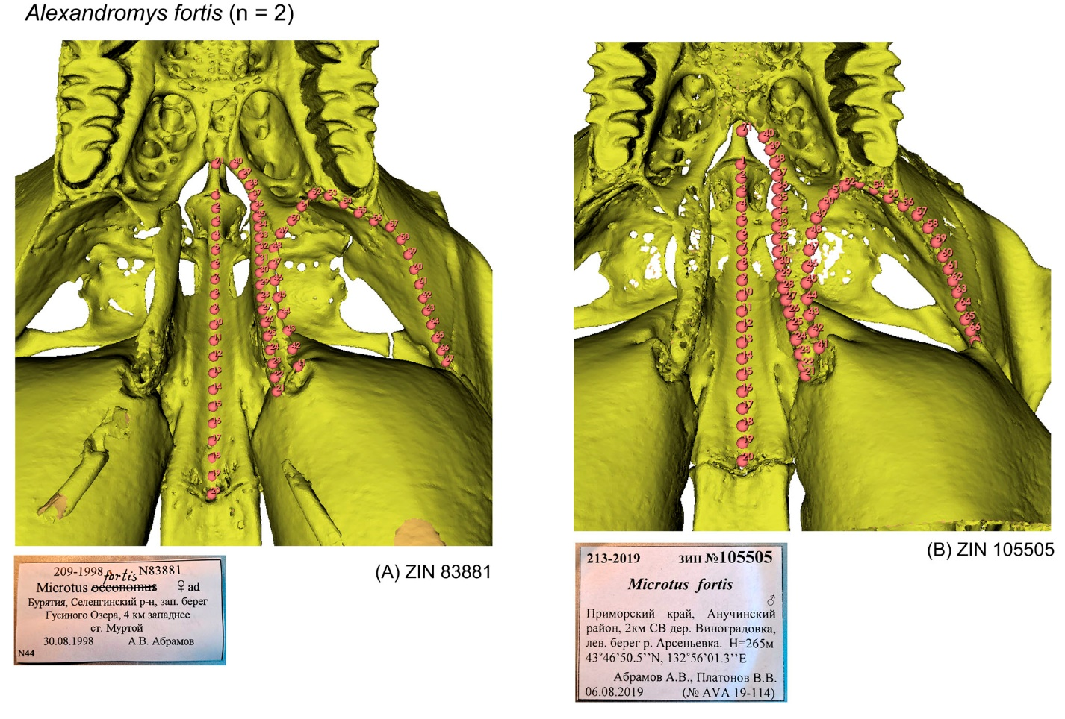

**Figure S38**. Screenshots of the PSP complex in subposterior view of six specimens of *Alexandromys oeconomus* with landmark positions: (A) ZIN 66013; (B) ZIN 89161; (C) ZIN 96546; (D) ZIN 98883; (E) ZIN 100612; (F) ZIN 101023.

See figure S36 for details. Not scaled.

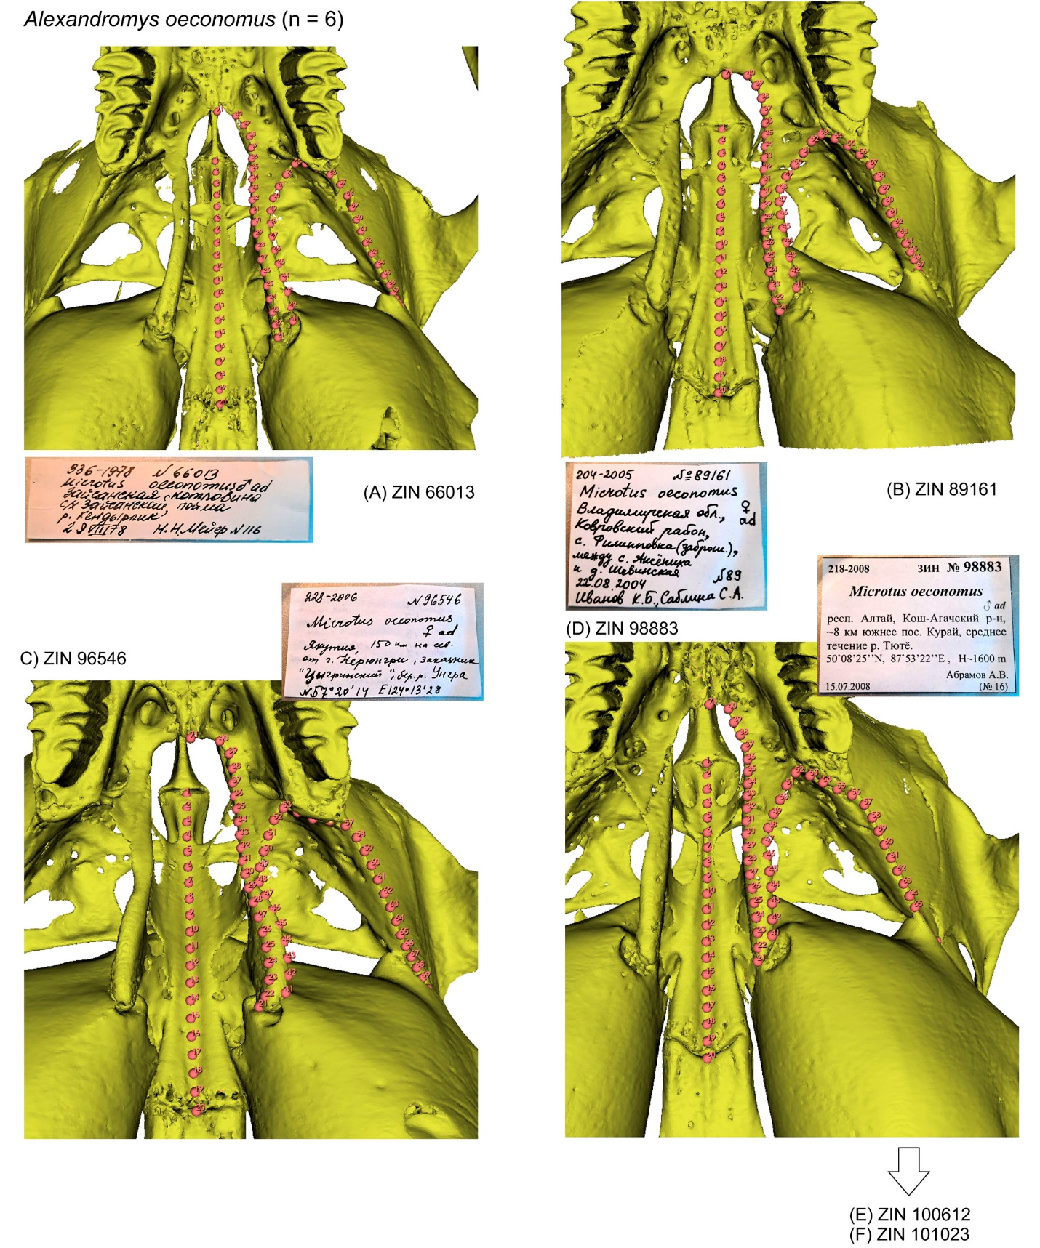

**Figure S38**. Continue.

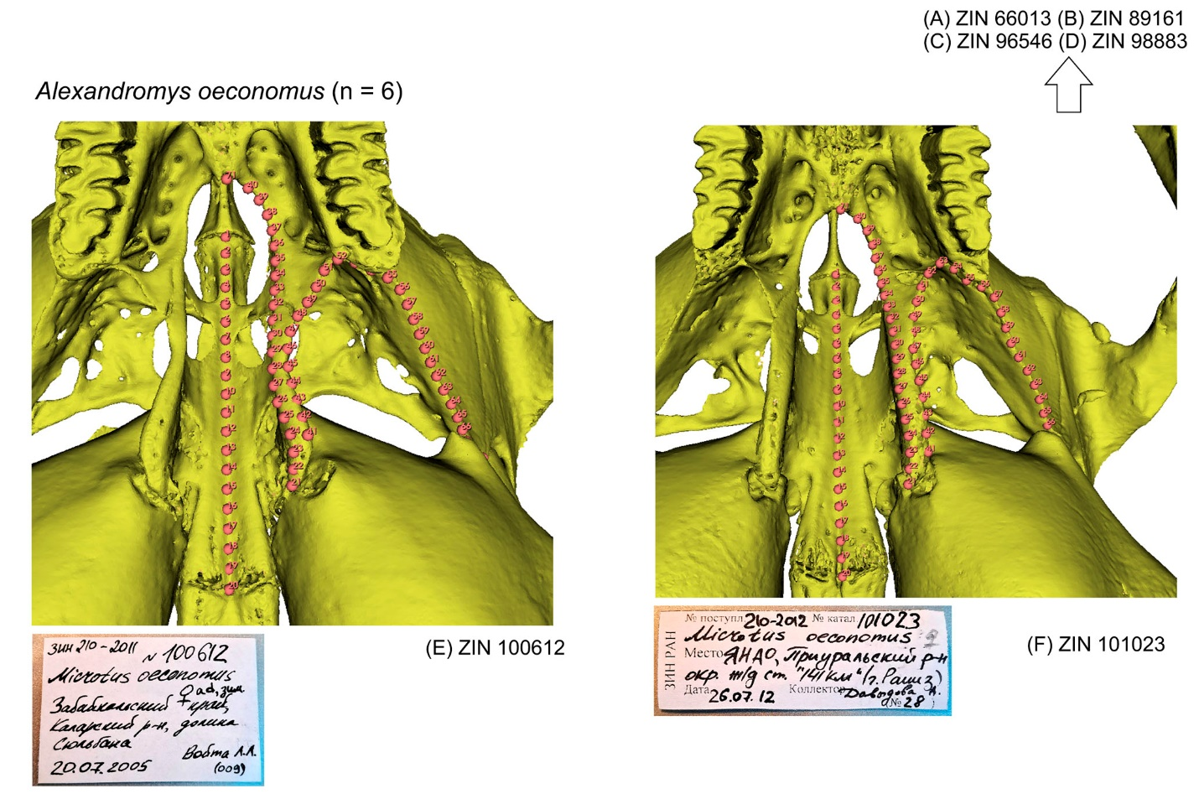

**Figure S39**. Screenshots of the PSP complex in subposterior view of four specimens of *Alticola argentatus* with landmark positions: (A) ZIN 77405; (B) ZIN 77458; (C) ZIN 77464; (D) ZIN 77489.

See figure S36 for details. Not scaled.

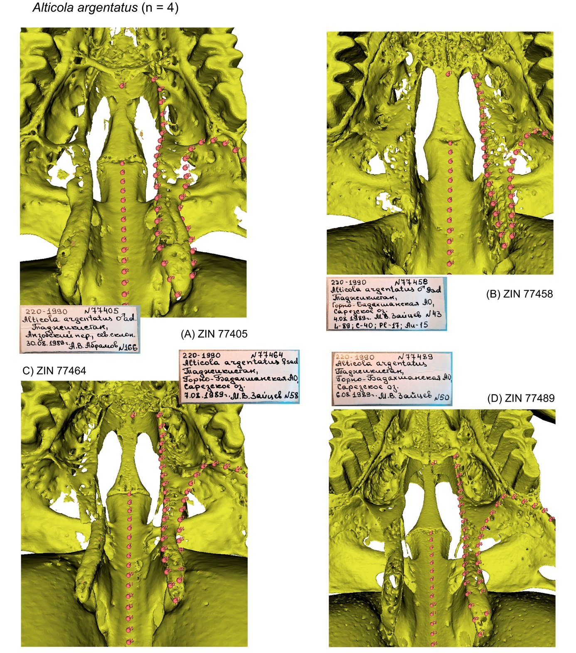

**Figure S40**. Screenshots of the PSP complex in subposterior view of two specimens of *Alticola lemminus* with landmark positions: (A) ZIN 101796; (B) ZIN 101797.

See figure S36 for details. Not scaled.

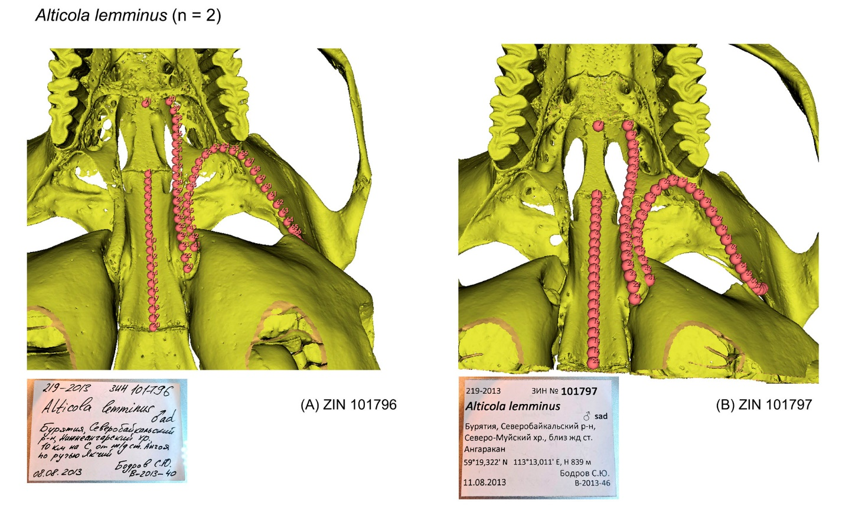

**Figure S41**. Screenshots of the PSP complex in subposterior view of three specimens of *Alticola macrotis* with landmark positions: (A) ZIN 102289; (B) ZIN 102307; (C) ZIN 99351.

See figure S36 for details. Not scaled.

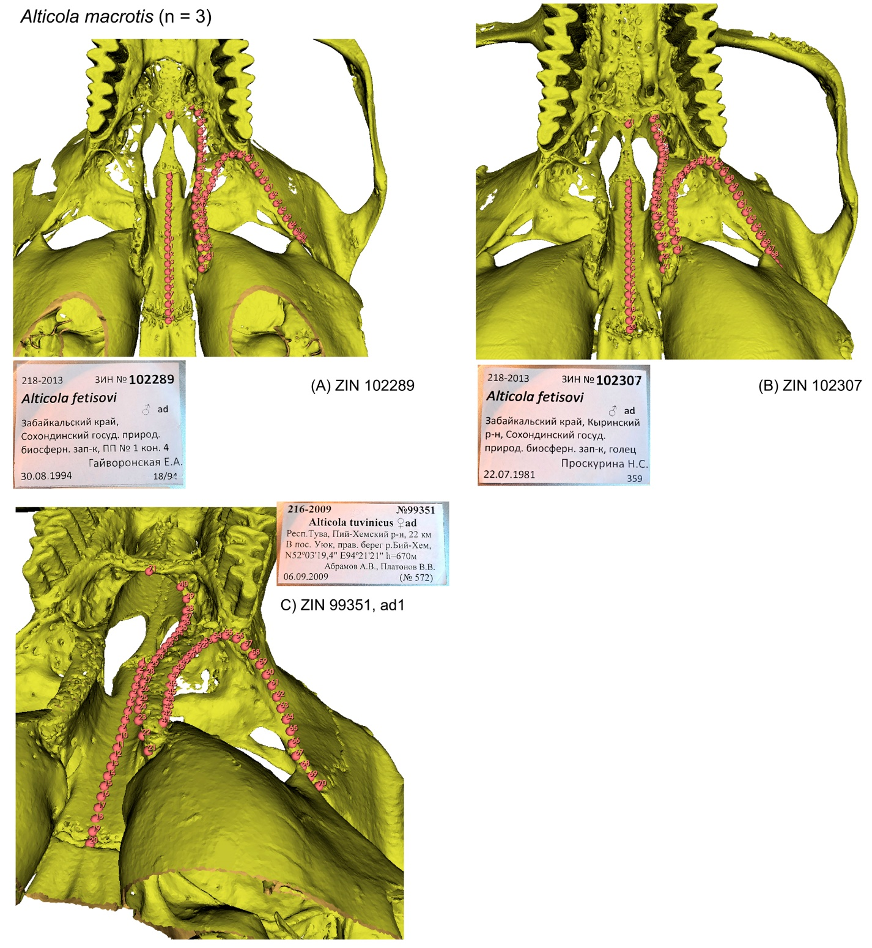

**Figure S42**. Screenshots of the PSP complex in subposterior view of two specimens of *Alticola semicanus* with landmark positions: (A) ZIN 107067; (B) ZIN 107068.

See figure S36 for details. Not scaled.

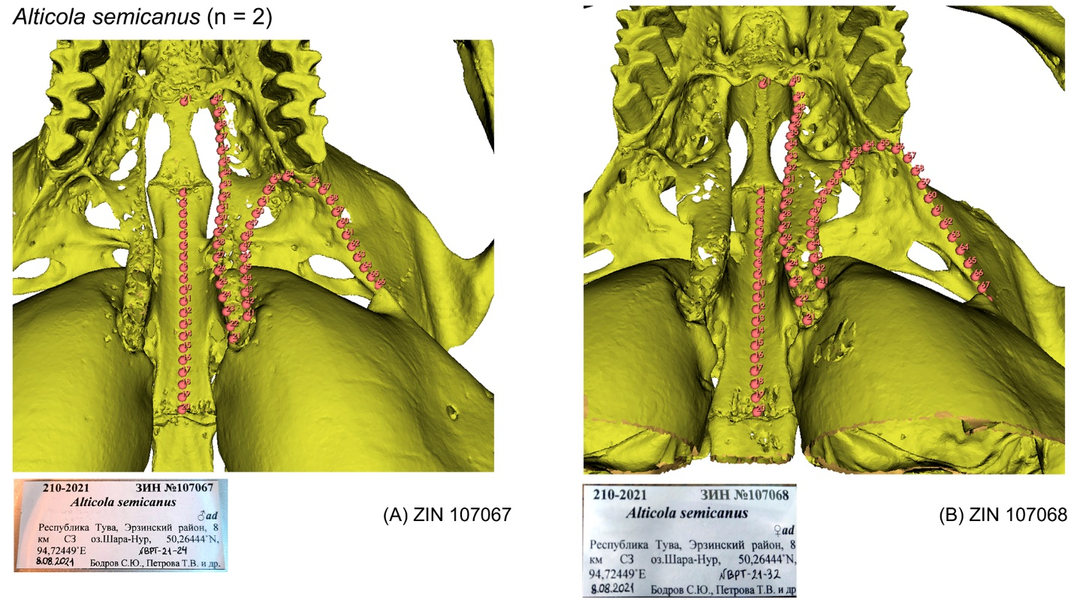

**Figure S43**. Screenshots of the PSP complex in subposterior view of three specimens of *Arvicola* *amphibius* with landmark positions: (A) ZIN 10034; (B) ZIN 16365; (C) ZIN 45399.

See figure S36 for details. Not scaled.

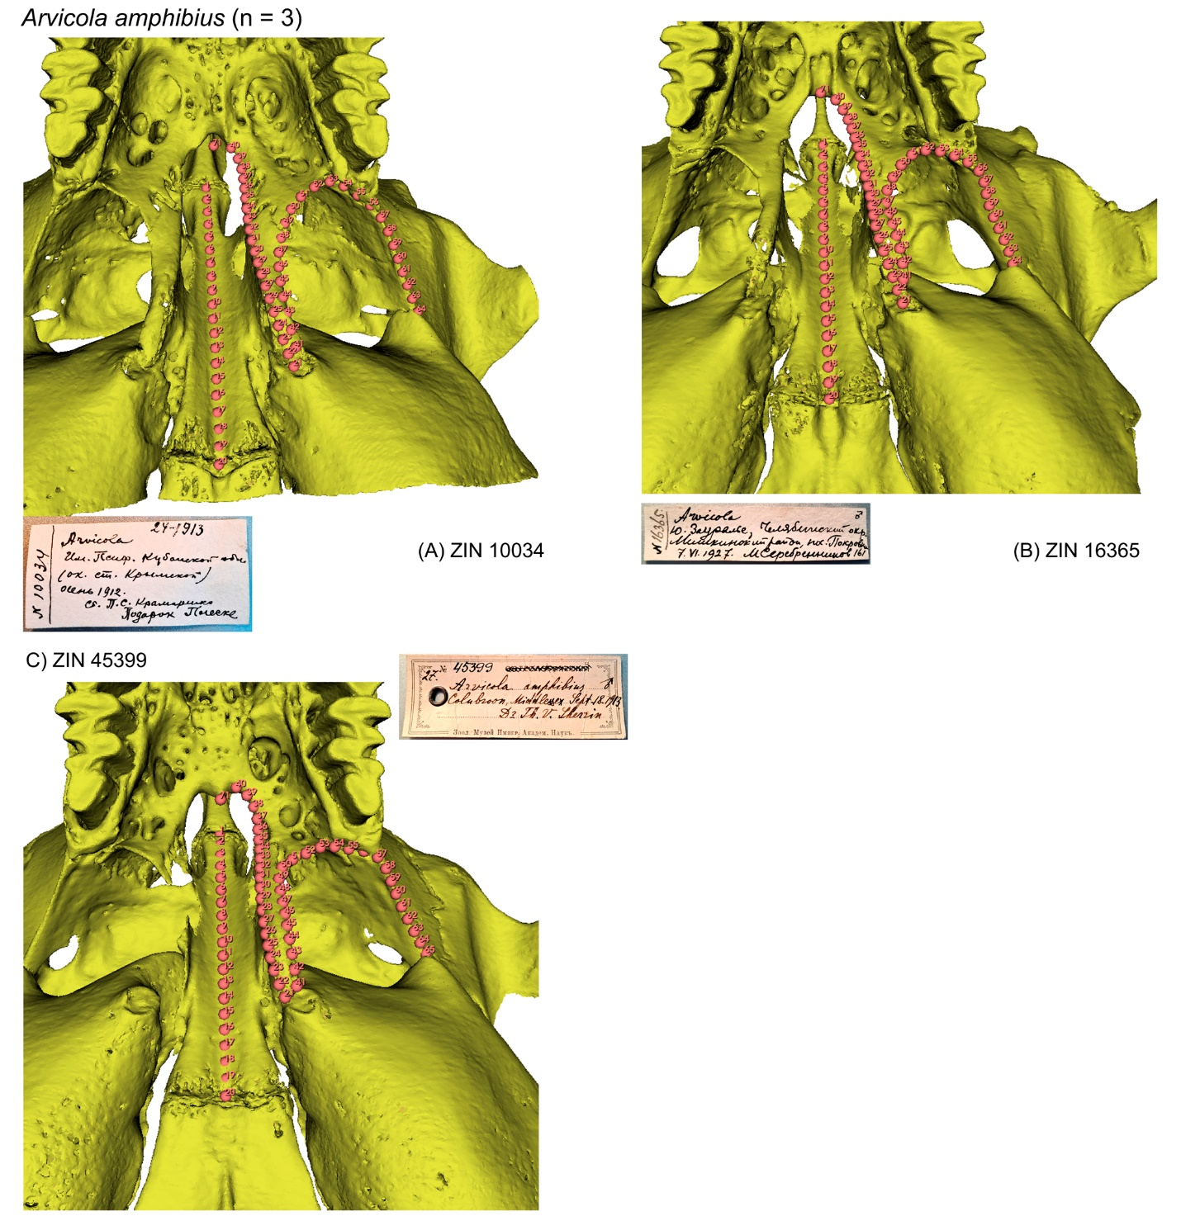

**Figure S44**. Screenshots of the PSP complex in subposterior view of three specimens of *Chionomys nivalis* with landmark positions: (A) ZIN 70703; (B) ZIN 71279; (C) ZIN 106369.

See figure S36 for details. Not scaled.

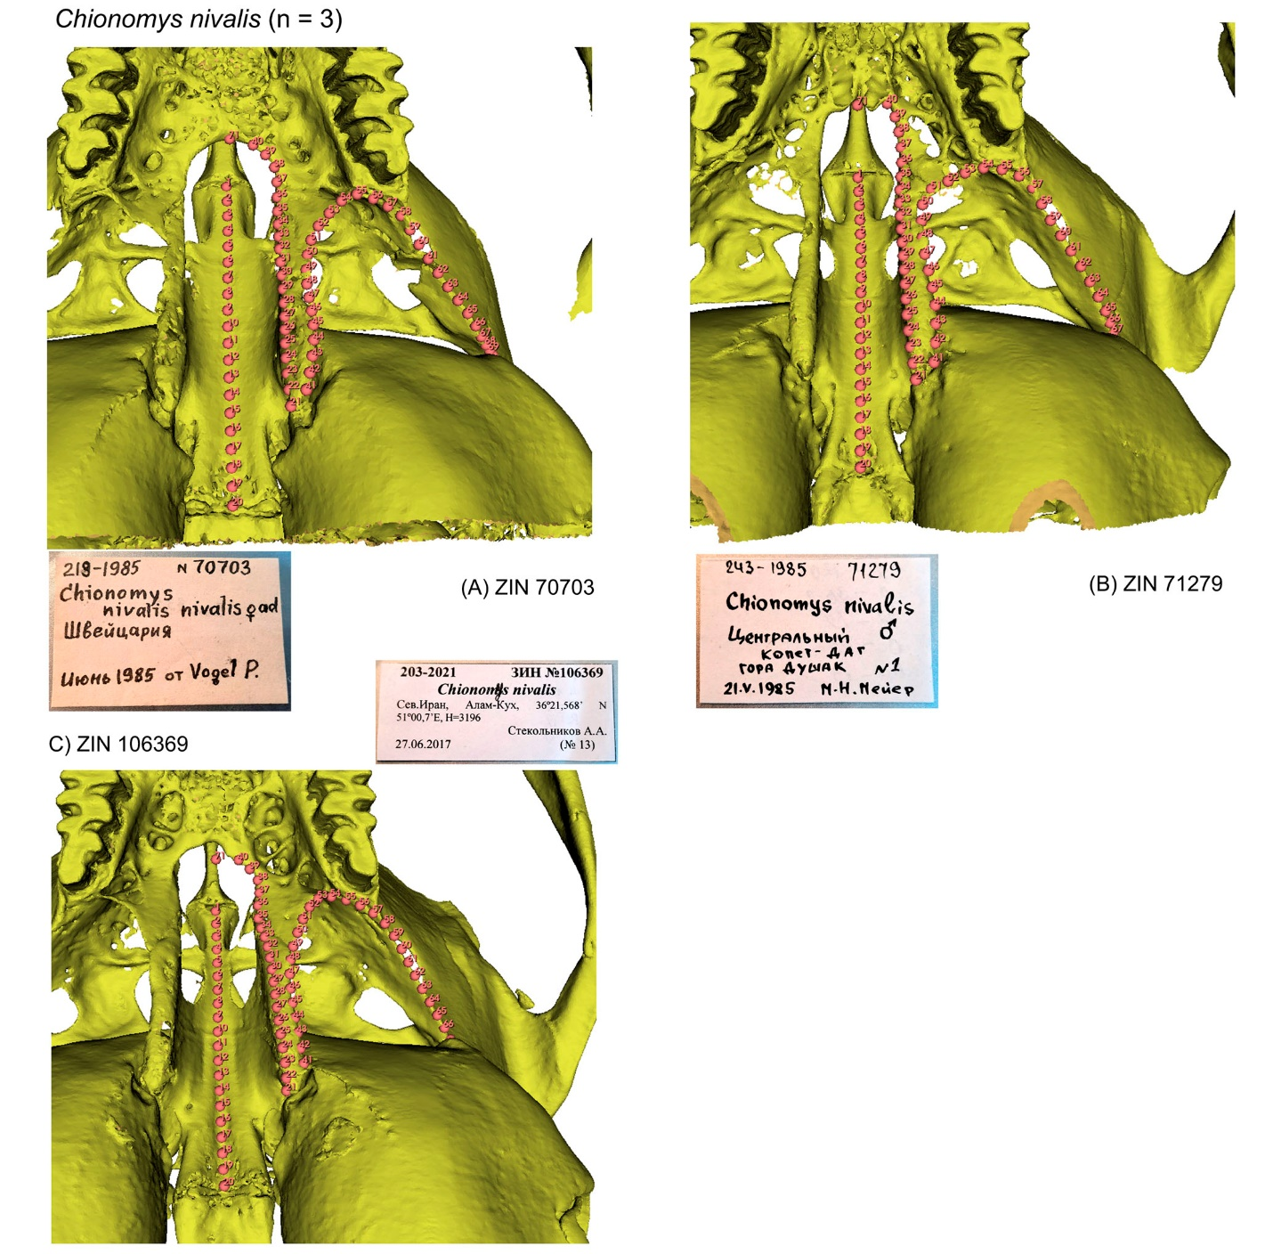

**Figure S45**. Screenshots of the PSP complex in subposterior view of three specimens of *Dicrostonyx torquatus* with landmark positions: (A) ZIN 81169; (B) ZIN 81254; (C) ZIN 81552.

See figure S36 for details. Not scaled.

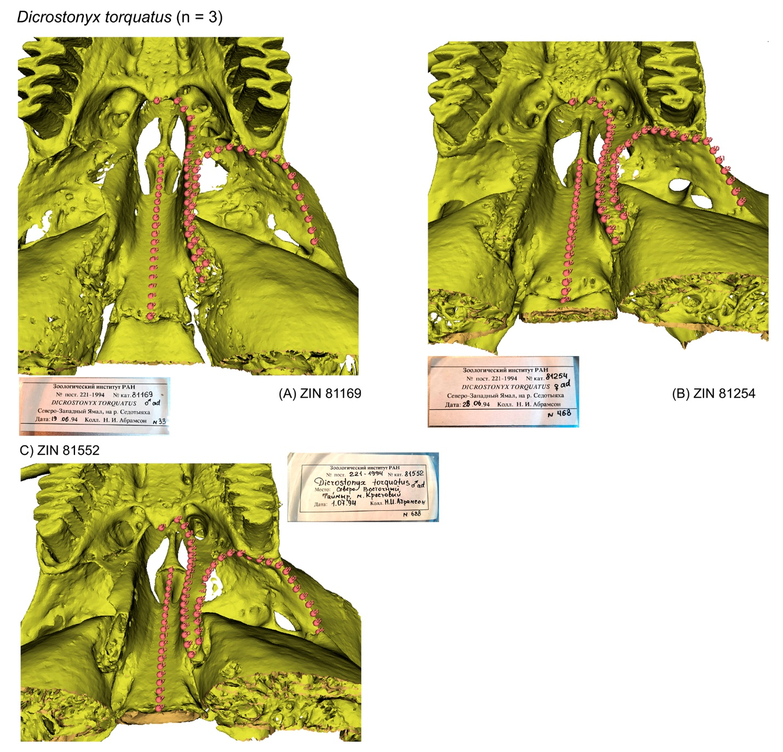

**Figure S46**. Screenshots of the PSP complex in subposterior view of two specimens of *Dinaromys bogdanovi* with landmark positions: (A) ZIN 34835; (B) ZIN 34887.

See figure S36 for details. Not scaled.

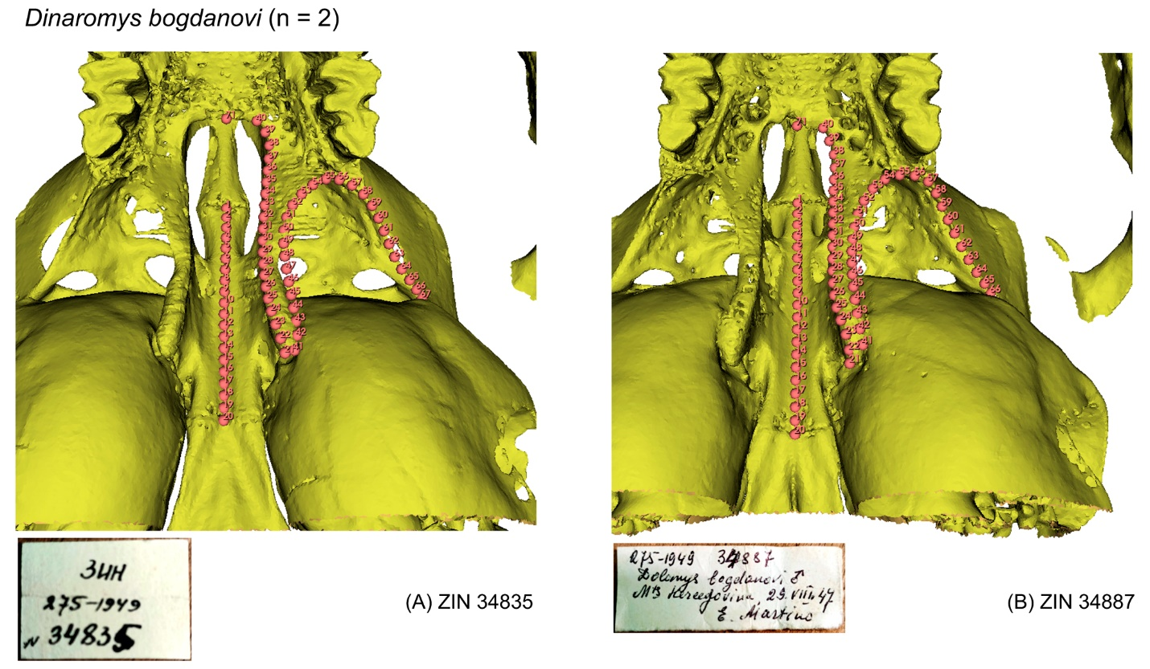

**Figure S47**. Screenshots of the PSP complex in subposterior view of four specimens of *Ellobius lutescens* with landmark positions: (A) ZIN 26607; (B) ZIN 83708; (C) ZIN 85284; (D) ZIN 85287.

See figure S36 for details. Not scaled.

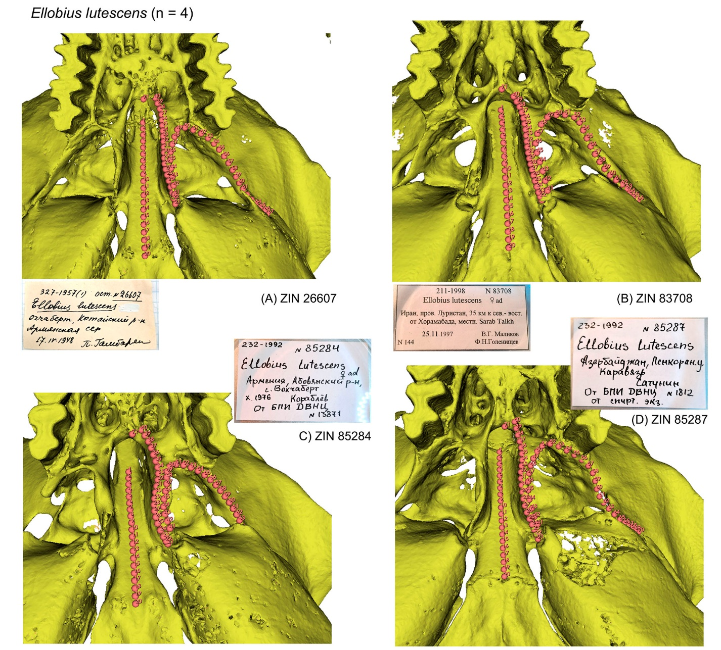

**Figure S48**. Screenshots of the PSP complex in subposterior view of five specimens of *Ellobius talpinus* with landmark positions: (A) ZIN 11763; (B) ZIN 35828; (C) ZIN 82955; (D) ZIN 84395; (E) ZIN 102342.

See figure S36 for details. Not scaled.

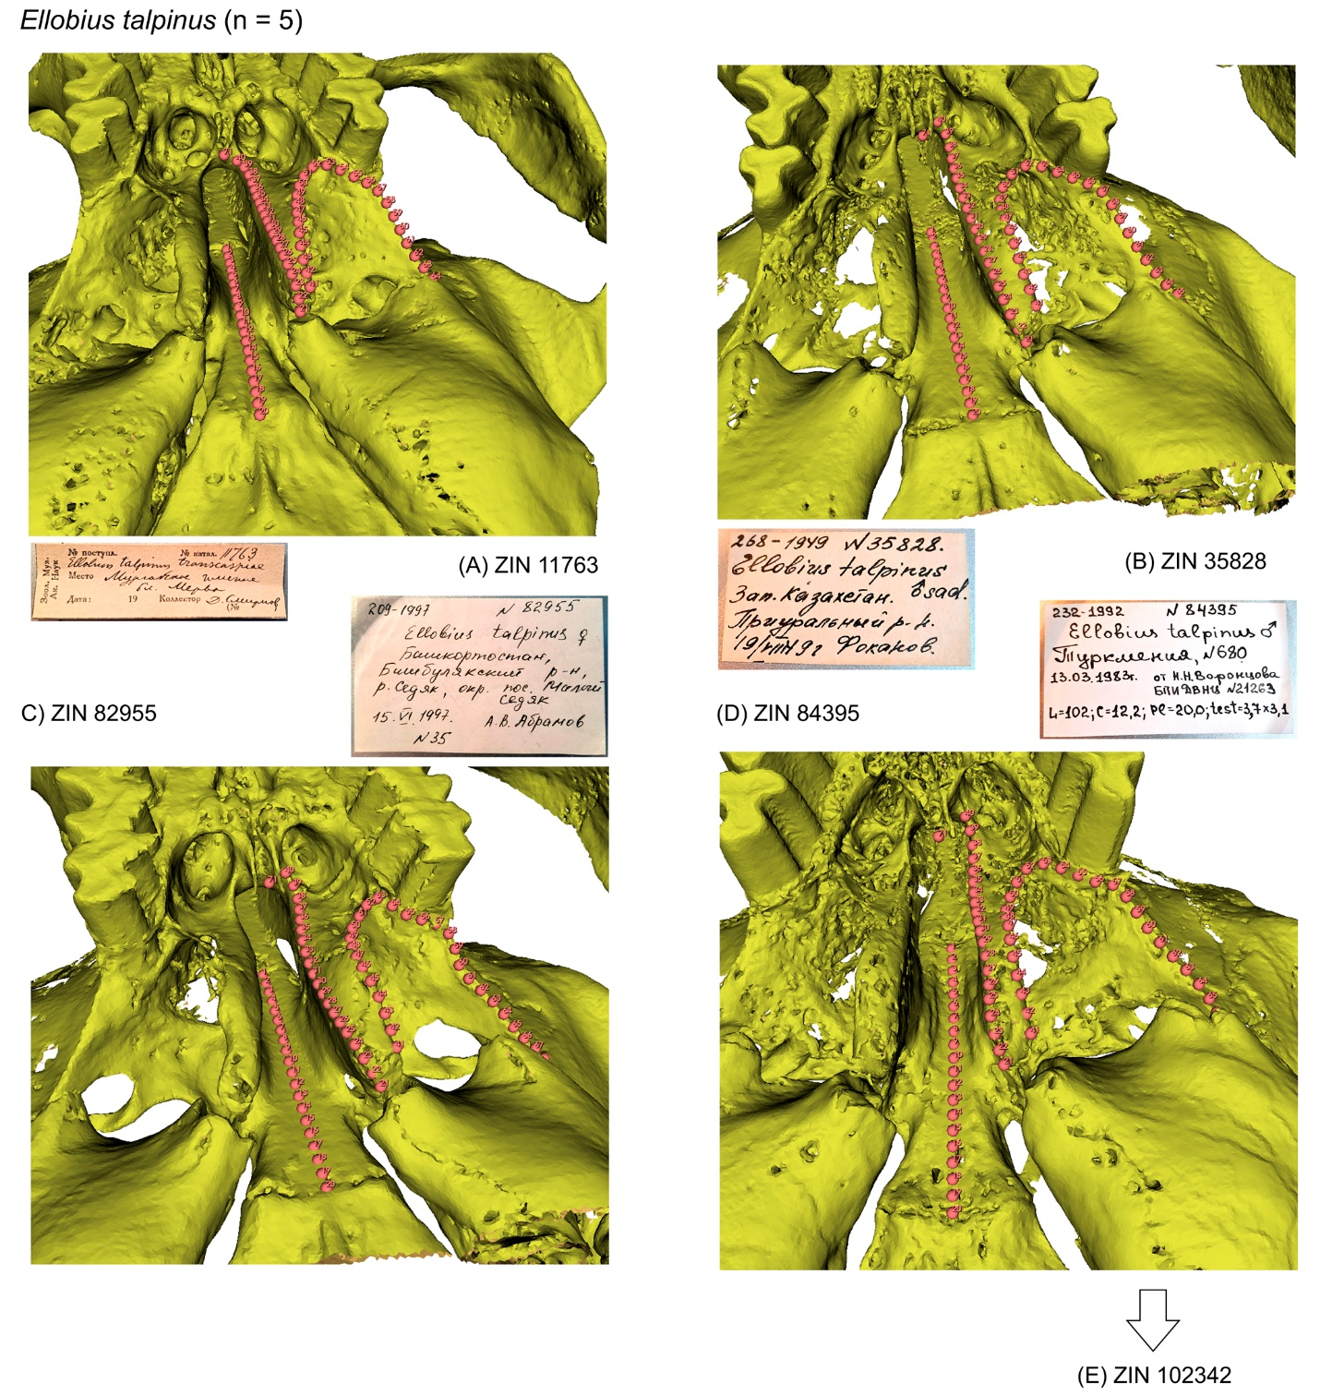

**Figure S48**. Continue.

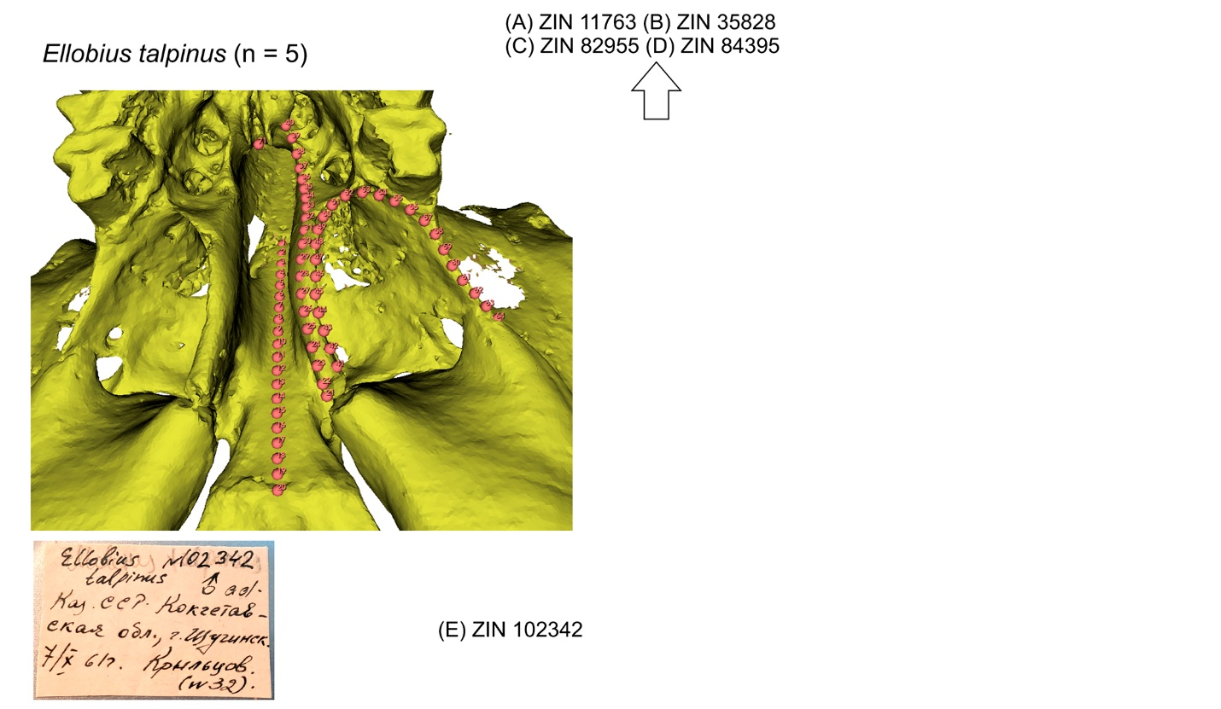

**Figure S49**. Screenshots of the PSP complex in subposterior view of two specimens of *Lagurus lagurus* with landmark positions: (A) ZIN 29170; (B) ZIN 57188.

See figure S36 for details. Not scaled.

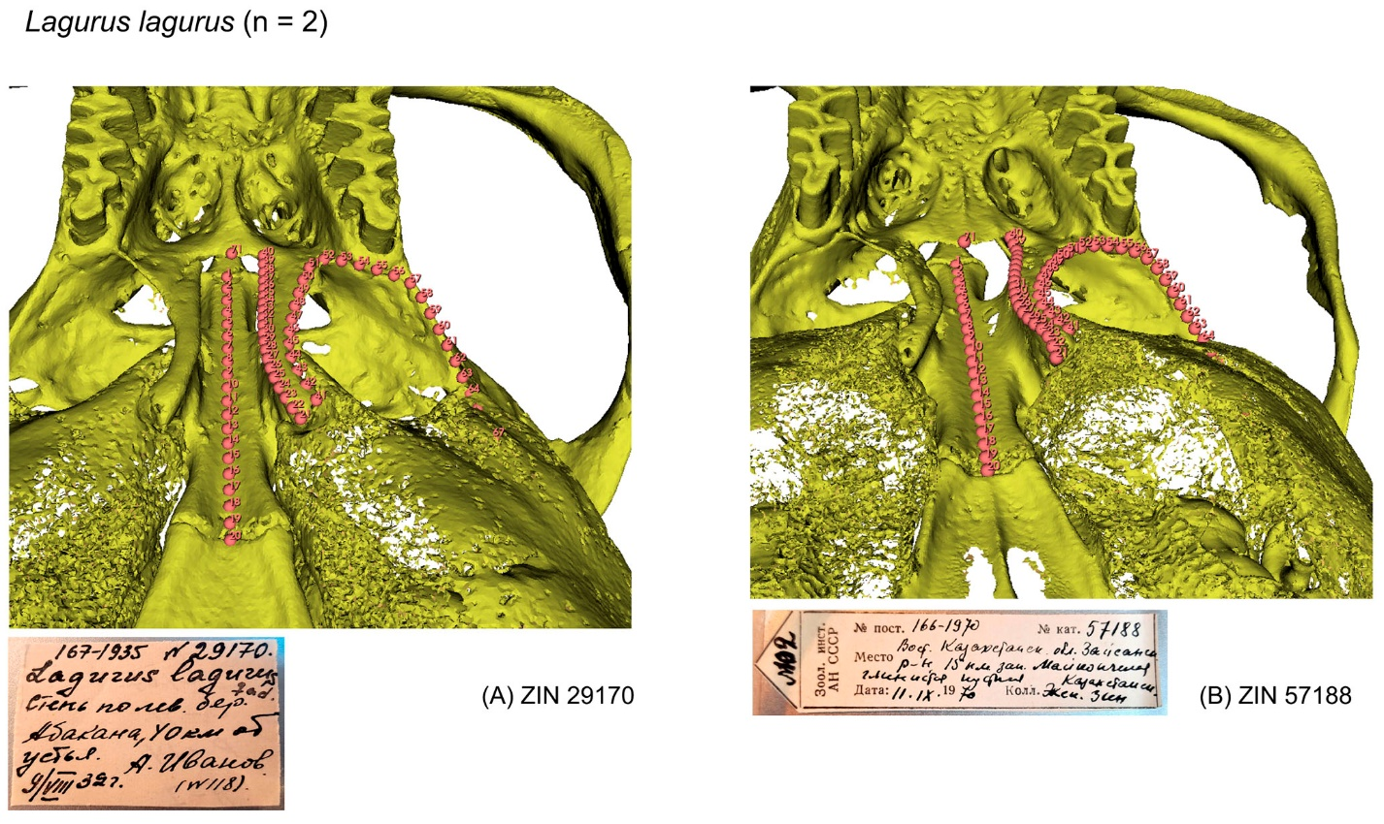

**Figure S50**. Screenshots of the PSP complex in subposterior view of two specimens of *Lasiopodomys brandtii* with landmark positions: (A) ZIN 82110; (B) ZIN 82114.

See figure S36 for details. Not scaled.

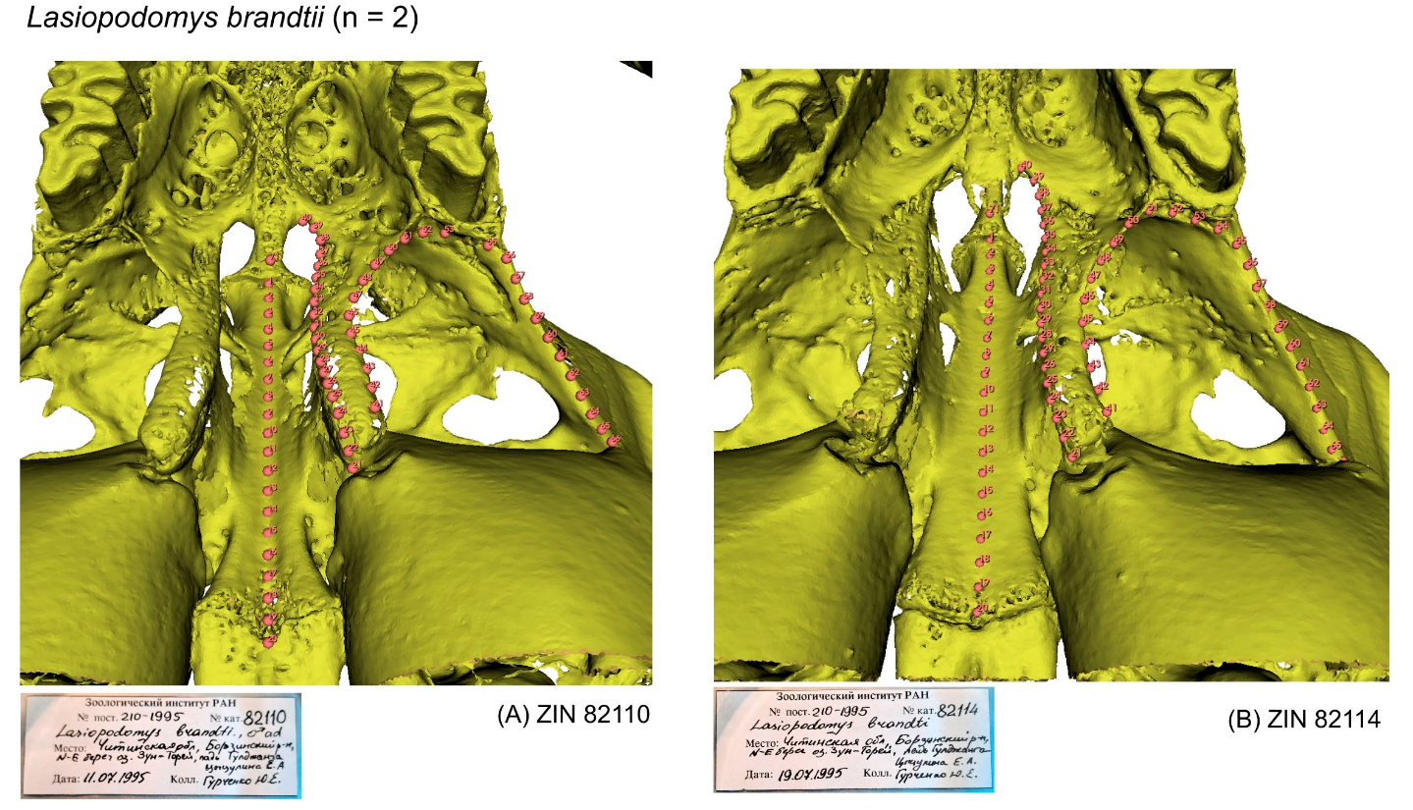

**Figure S51**. Screenshots of the PSP complex in subposterior view of four specimens of *Lasiopodomys gregalis* with landmark positions: (A) ZIN 15332; (B) ZIN 53120; (C) ZIN 96293; (D) ZIN 103094.

See figure S36 for details. Not scaled.

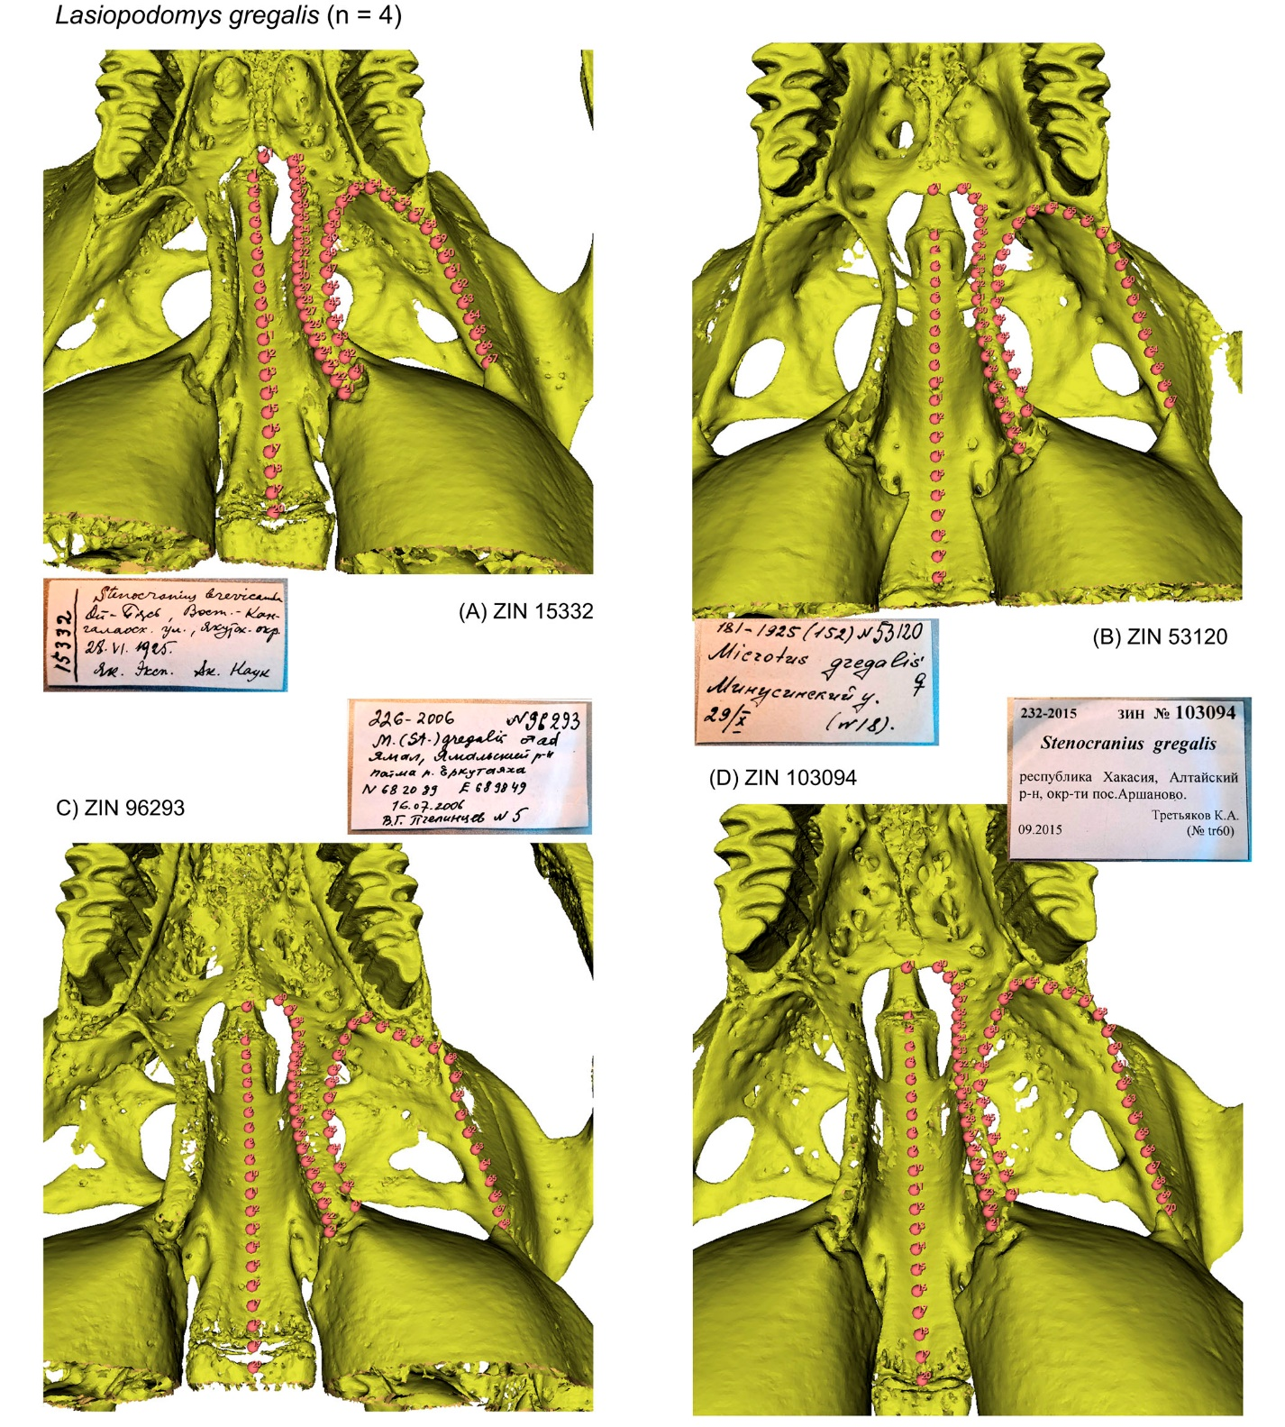

**Figure S52**. Screenshots of the PSP complex in subposterior view of two specimens of *Lasiopodomys mandarinus* with landmark positions: (A) ZIN 78327; (B) ZIN 78614.

See figure S36 for details. Not scaled.

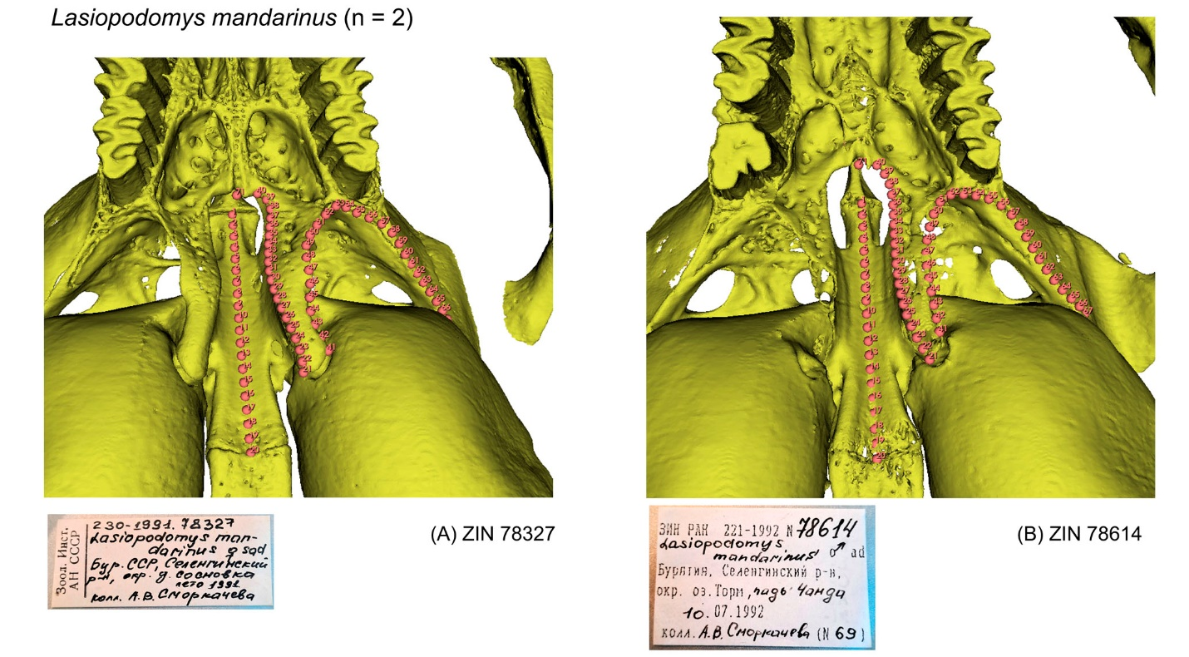

**Figure S53**. Screenshots of the PSP complex in subposterior view of four specimens of *Lasiopodomys raddei* with landmark positions: (A) ZIN 101665 (B) ZIN 105338; (C) ZIN 105341; (D) ZIN 105344.

See figure S36 for details. Not scaled.

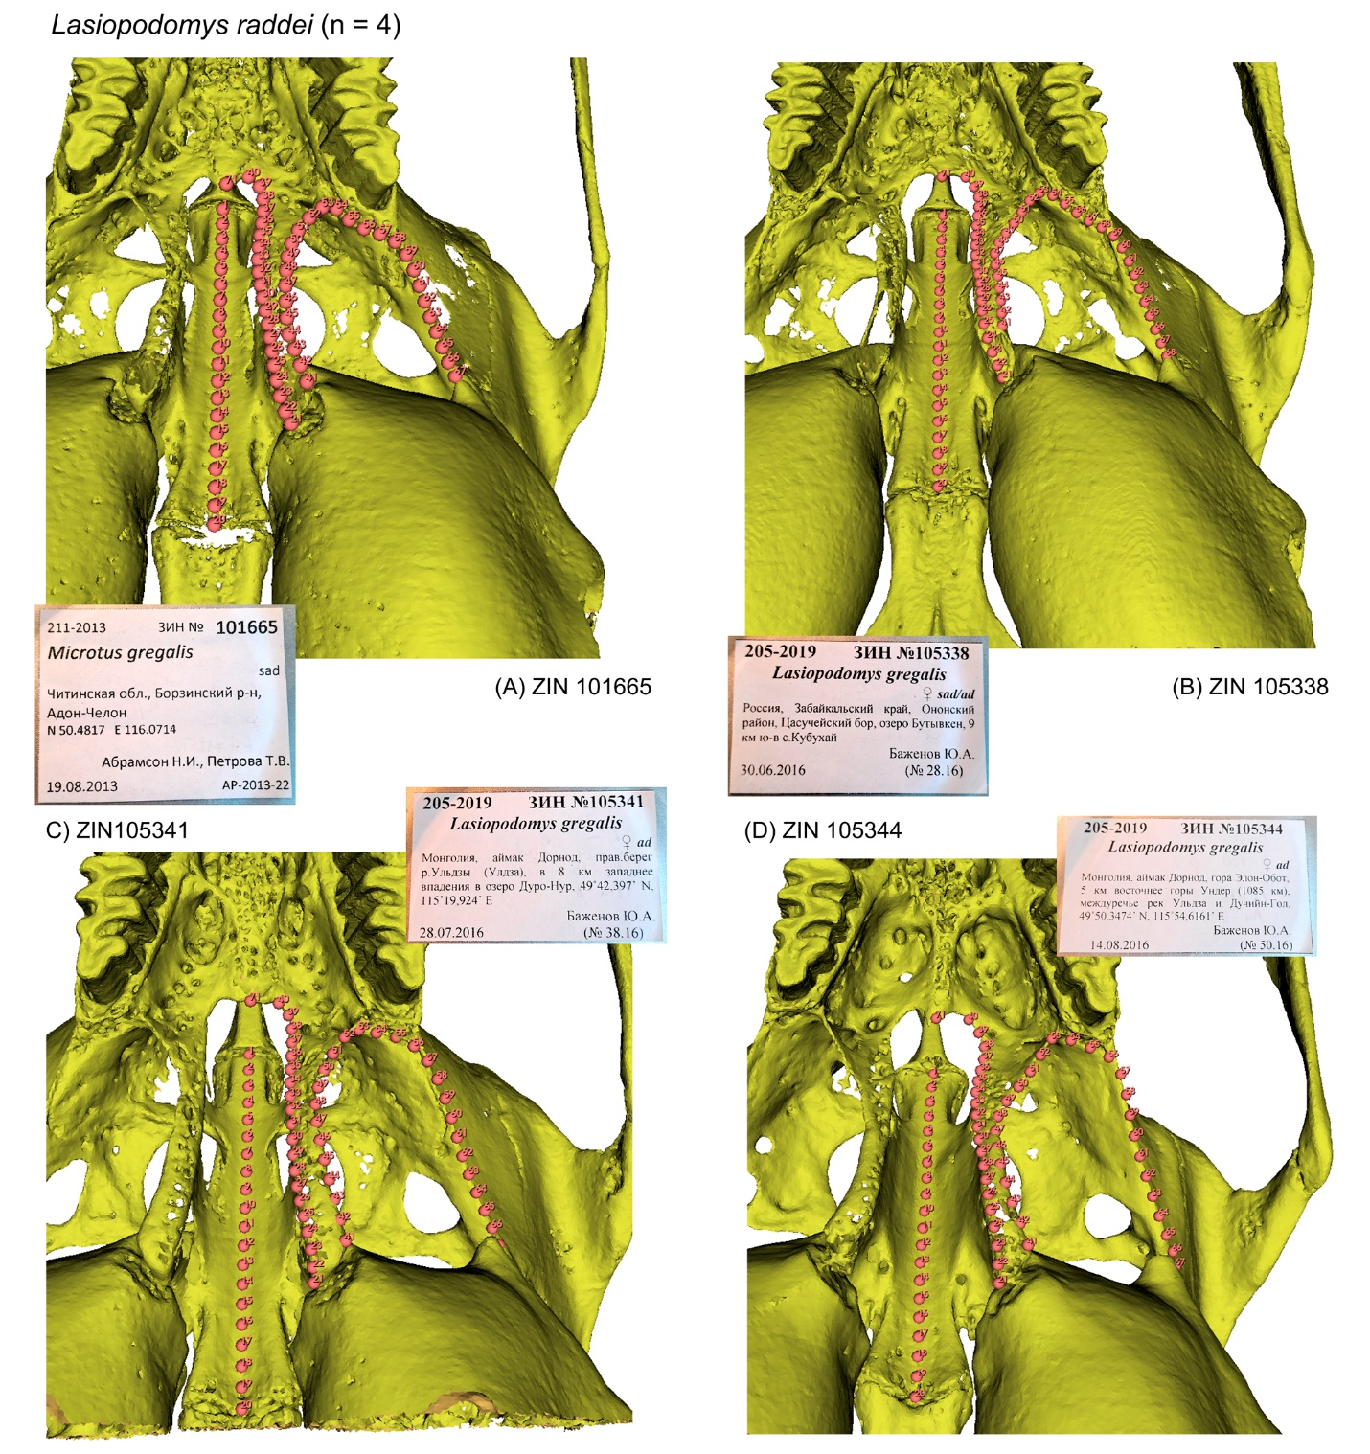

**Figure S54**. Screenshots of the PSP complex in subposterior view of three specimens of *Lemmus sibiricus* with landmark positions: (A) ZIN 64159; (B) ZIN 81239; (C) ZIN 81241.

See figure S36 for details. Not scaled.

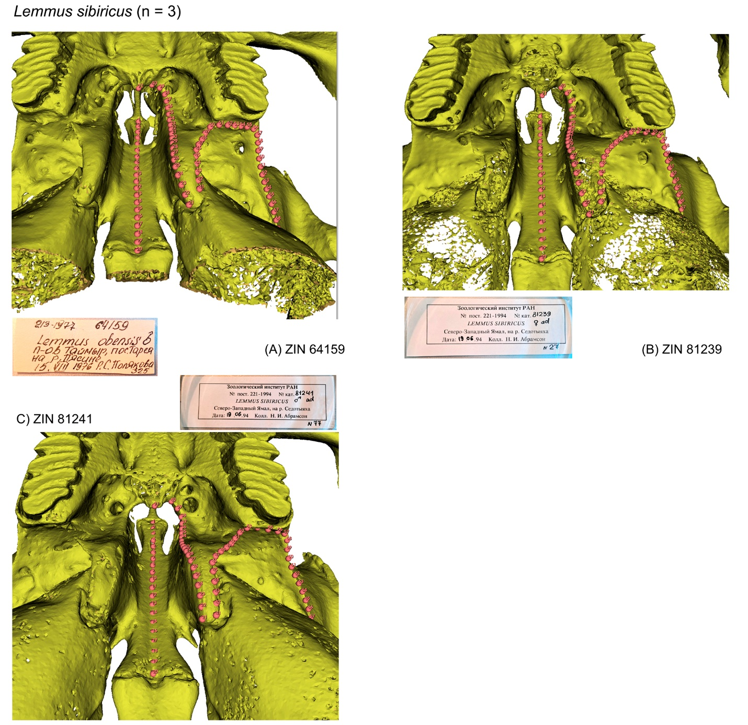

**Figure S55**. Screenshots of the PSP complex in subposterior view of two specimens of *Microtus arvalis* with landmark positions: (A) ZIN 19431; (B) ZIN 56750 (neotype).

See figure S36 for details. Not scaled.

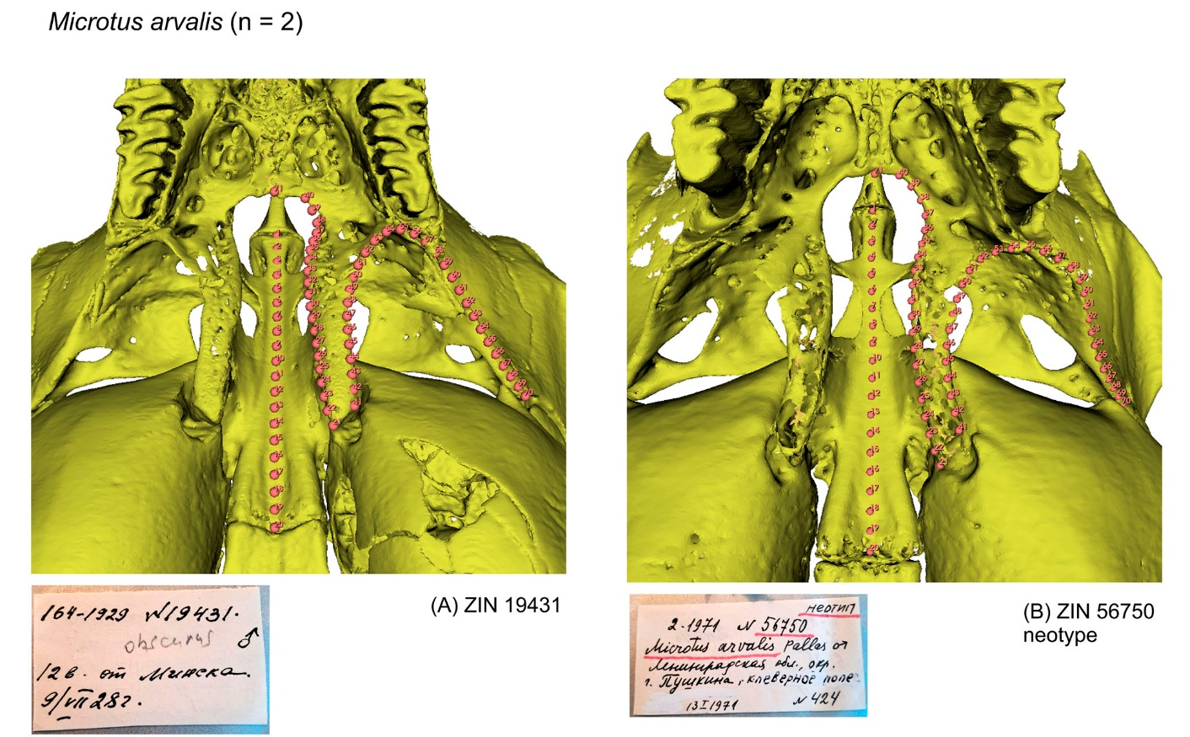

**Figure S56**. Screenshots of the PSP complex in subposterior view of three specimens of *Mynomes pennsylvanicus* with landmark positions: (A) ZIN 39888 (B) ZIN 74351; (C) ZIN 83753(6951).

See figure S36 for details. Not scaled.

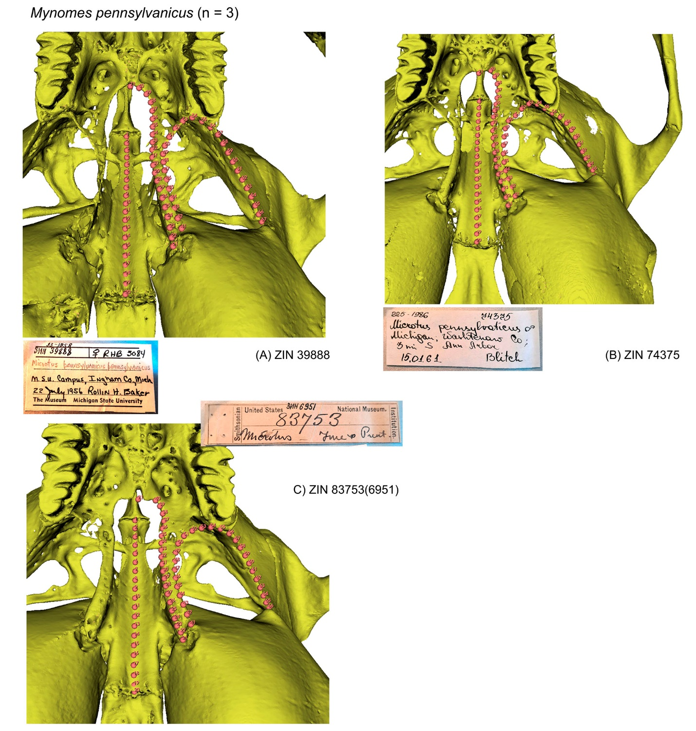

**Figure S57**. Screenshots of the PSP complex in subposterior view of two specimens of *Myodes centralis* with landmark positions: (A) ZIN 21254; (B) ZIN 107137.

See figure S36 for details. Not scaled.

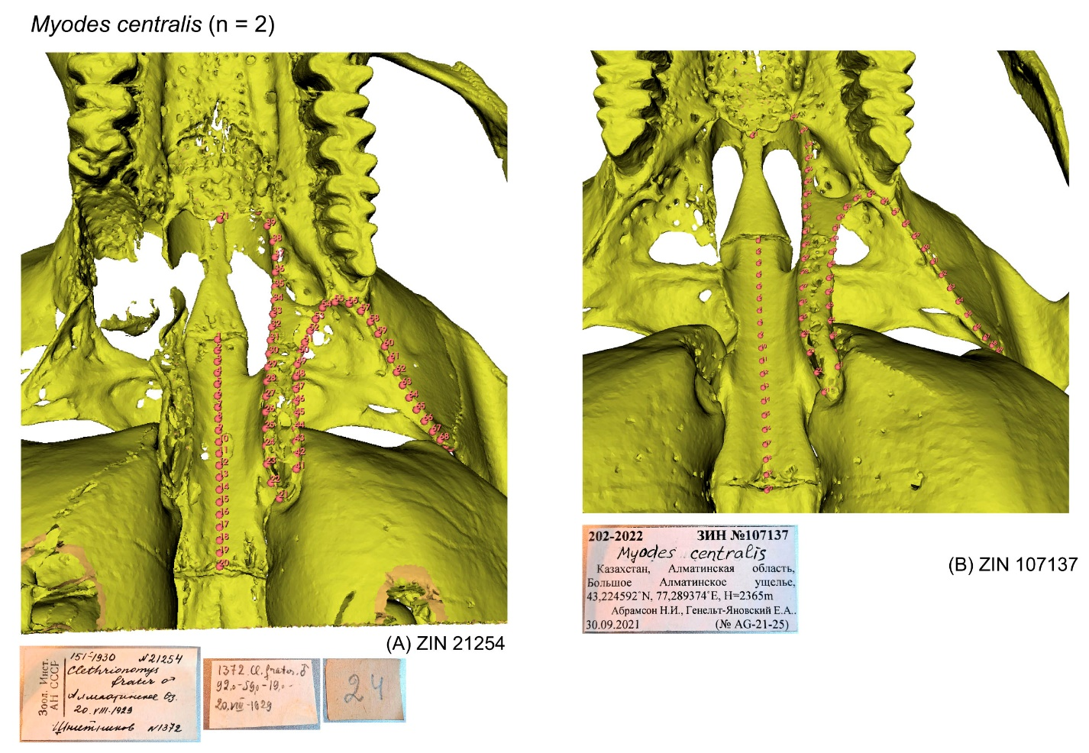

**Figure S58**. Screenshots of the PSP complex in subposterior view of four specimens of *Myodes rutilus* with landmark positions: (A) ZIN 20967; (B) ZIN 20974; (C) ZIN 20978; (D) ZIN 20984.

See figure S36 for details. Not scaled.

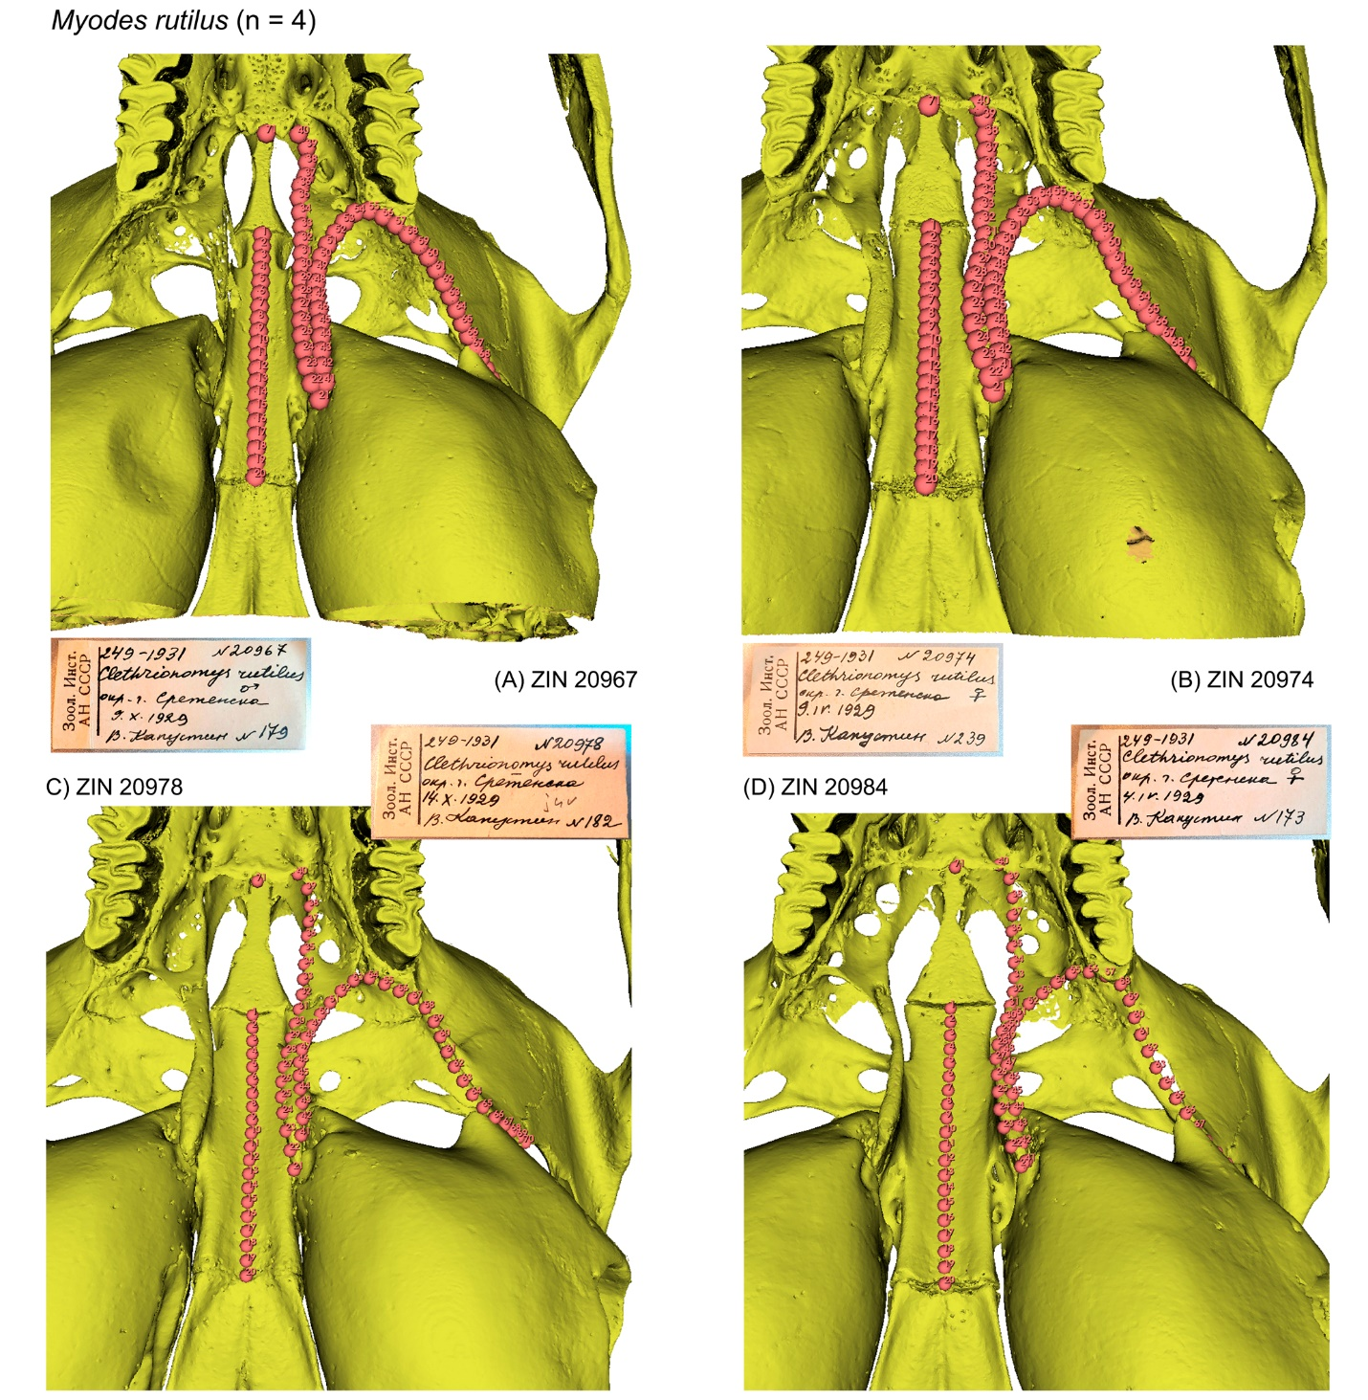

**Figure S59**. Screenshots of the PSP complex in subposterior view of two specimens of *Myopus schisticolor* with landmark positions: (A) ZIN 100554; (B) ZIN 103730.

See figure S36 for details. Not scaled.

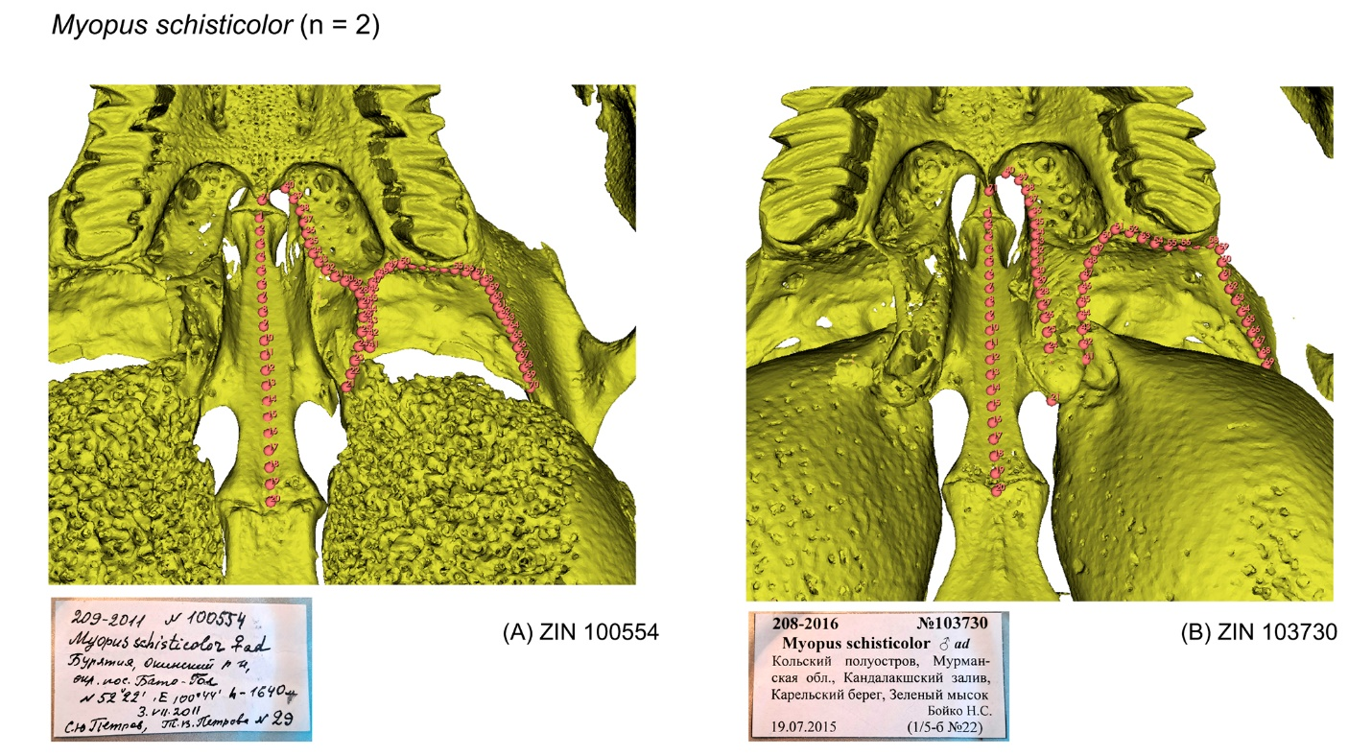

**Figure S60**. Screenshots of the PSP complex in subposterior view of three specimens of *Ondatra zibethicus* with landmark positions: (A) ZIN 32560; (B) ZIN 69584; (C) ZIN 84176.

See figure S36 for details. Not scaled.

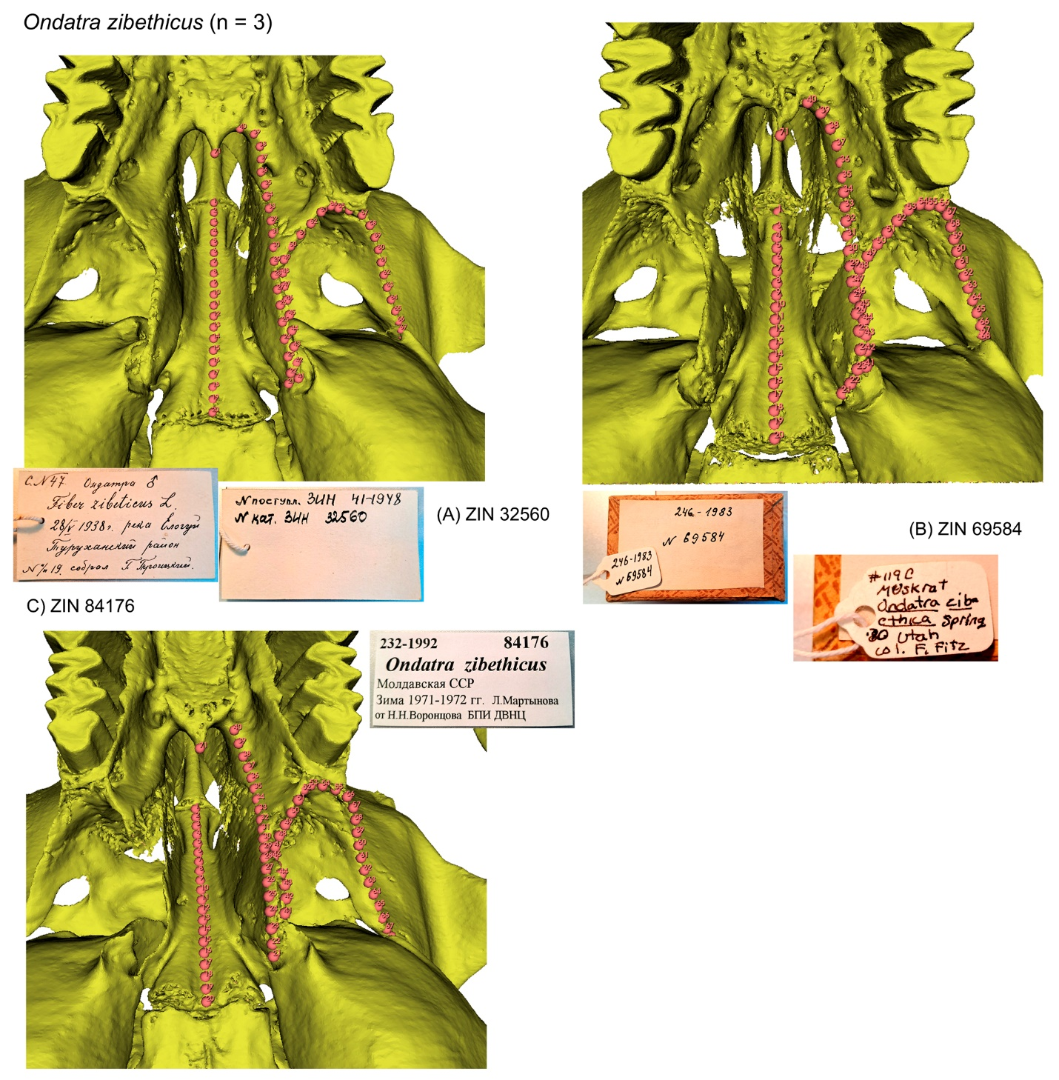

**Figure S61**. Screenshots of the PSP complex in subposterior view of two specimens of *Prometheomys schaposchnikowi* with landmark positions: (A) ZIN 31495; (B) ZIN 74487.

See figure S36 for details. Not scaled.

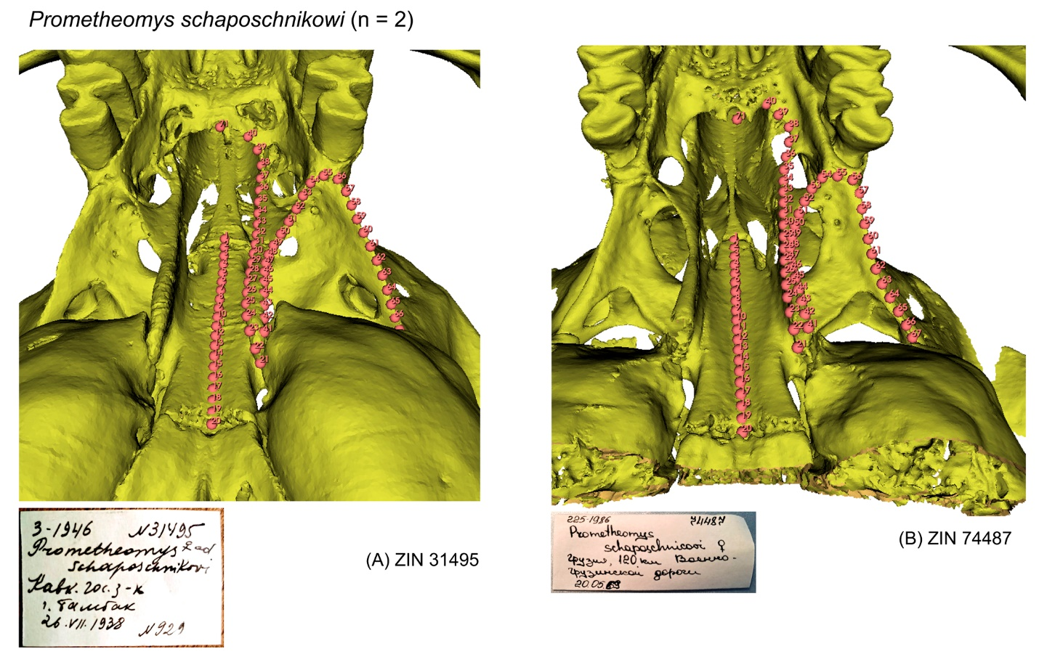

**Figure S62**. Screenshots of the PSP complex in subposterior view of three specimens of *Terricola subterraneus* with landmark positions: (A) ZIN 74969; (B) ZIN 80937; (C) ZIN 84244.

See figure S36 for details. Not scaled.

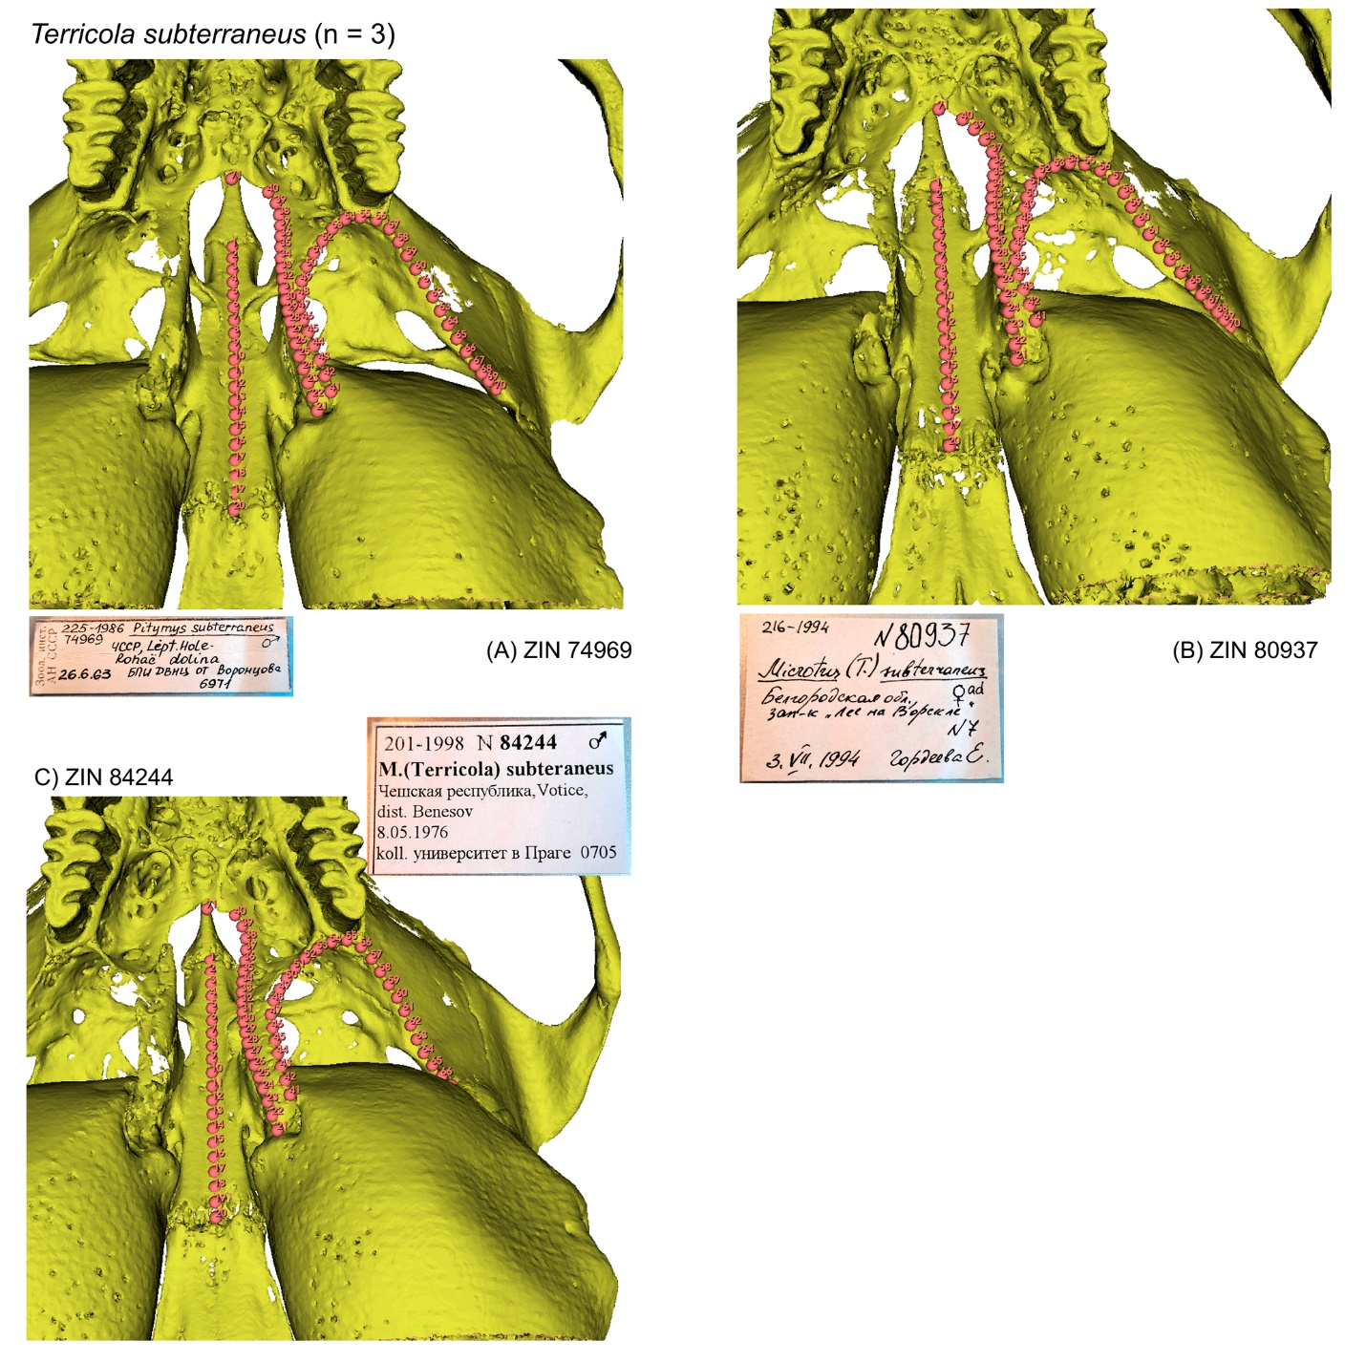

**Figure S63**. Screenshots of the PSP complex in subposterior view of two specimens of *Neotoma mexicana* with landmark positions: (A) ZIN 39375; (B) ZIN 39376.

See figure S36 for details. Not scaled.

